A watershed-specific formula to predict coho salmon reproduction using river flow metrics

Claire Kouba, Jason Weiner and Thomas Harter

Nov. 2023

# Abstract

In many rural areas in arid and semi-arid regions, balancing agricultural and environmental water demands is a key challenge facing resource managers. Although flow-ecology relationships are well-studied, the water needs of cultivated crops are generally better understood than those of aquatic ecosystems. In particular, the timing and magnitude of flow needed to sustain key ecological functions remain poorly quantified in many regions. This work aims to quantify hydrologic conditions that support persistence of key ecosystem species. We use the coho (*Oncorhynchus kisutch*) and Chinook (*Oncorhynchus tshawytscha*) salmon run in Scott Valley, a 2,109 km2 undammed rural watershed in northern California, USA, as a case study. We applied the functional flows framework to characterize the hydrology of each water year measured at a key long-term stream gauge. Taking advantage of a nearly two-decade ecological monitoring dataset, we built linear models to predict coho and Chinook salmon reproductive success using combinations of one and two hydrologic metric predictors. We found that reproduction in coho salmon was more related to hydrology than in Chinook salmon. For coho, we used an ensemble of the three best linear models (based on predictors related to the timing of the dry-to-wet season transition and wet season duration) to formulate a Hydrologic Benefit function, summarizing the ecological services provided by the hydrology in different seasons into a single index value per water year. This method for empirically deriving the highest-priority hydrologic functions for a threatened species could be used in other watersheds (if sufficient ecological data records are available, and if flow-hydrology relationships are identifiable for a given species) to evaluate trade-offs and support water management decisions in human-altered novel ecosystems.

# 1 Introduction

## 1.1 Motivation and objectives

Reconciliation ecology posits that some human-impacted ecosystems should be considered irrevocably-altered, “novel” systems (Moyle 2014), with their own specific management concerns. To implement this philosophy, rather than working to restore novel ecosystems to pre-human conditions, a natural resource manager would embrace a role as earth system engineer, and would actively manage biodiversity in human-altered landscapes as a co-equal goal with extracting and cultivating natural resources to provide for human material needs (e.g., Robertson and Swinton 2005; Arthington, Bernardo, and Ilhéu 2014; Acreman et al. 2014). But critical knowledge gaps are abundant and make this dual objective seem intractable. In many river ecosystems, though general methods to characterize environmental flows have been in wide use for at least a decade (e.g., Poff and Zimmerman 2010; Shenton et al. 2012; Solans and García de Jalón 2016), the regional-scale conditions that would maintain biodiversity are as yet unquantified or highly uncertain (Poff et al. 2010). Higher certainty in quantitative ecological targets could support more robust decision making and trade-off analysis, potentially answering questions like: how close can managers get to the desired ecological conditions, and at what cost, particularly in a changing climate?

In practice, these questions are often asked and answered locally (Tarlock 1993). The entities managing natural resources, and thus determining the regional persistence of non-human species, are typically the communities living and working with local resources. Reflecting this reality, the authors of this study have posed research questions tailored to conserving two specific salmon species, the threatened coho salmon (*Oncorhynchus kisutch*) and the less-threatened Chinook salmon (*Onchorhynchus tshawytscha*), in a specific study area: the Scott River watershed in northern California, USA. In this undammed, rural watershed, the primary way to manage water use is by managing land use, and balancing the competing water needs of fish and farmers is a key challenge for local water managers (Siskiyou County 2021). Agricultural water needs are well-known and can be estimated and scheduled (Siskiyou RCD 1994; Parry 2013; DWR 2021), but, in spite of decades of investigation by local, state and federal actors (e.g., SRWC and Siskiyou RCD 2003; NMFS 2014; CDFW 2015b; CDFW 2021), the ecological water needs in this balancing act are not as well constrained.

One method for estimating ecological water needs is the functional flows framework (Poff et al. 1997; Poff and Zimmerman 2010). Functional flow metrics are used to quantify potential ecological services provided by river flow in terms of flowrate amplitude, timing, frequency, and duration in distinct seasons of a water year, where water year is here defined to begin on October 1 of the year preceding the calendar year of the same number (i.e., water year 2020 begins on October 1, 2019). Recent work has refined these metrics for California hydrology and made the metric-calculating algorithms publicly available (Yarnell et al. 2020; Patterson et al. 2020).

To learn if it is possible to empirically quantify a hydrologic regime that meets the ecological needs of specific species (coho and Chinook salmon) in a specific ecological region (the Scott River watershed), we examine correlations between several dozen hydrologic metrics and local salmon observations. We then use linear models to predict salmon outcomes based on potential combinations of hydrologic metric predictors. We use the best of these linear models to formulate a Hydrologic Benefit function for each species, distilling the varying ecological services provided by hydrology across different seasons into a single index value per water year. This work sets the stage for a quantitative comparison of competing natural resource management alternatives.

## 1.2 History of flow-ecology relationships

A river’s flow regime is often referred to as a “master variable” controlling geomorphic, chemical, and other conditions in its aquatic ecosystems, and organisms that have evolved to persist in specific flow regimes are commonly negatively affected by flow alteration (Bunn and Arthington 2002; Poff and Zimmerman 2010). Consequently, in recent decades a diverse body of research has sought to identify and quantify ecological responses to changes in flow. Work on this topic spans multiple categories of ecological response, hydrologic predictor, and ultimate cause of hydrologic alteration. Two widely studied ecological response metric categories are, firstly, the stream health index, based on density and species richness of macroinvertebrates observed at designated sampling sites (e.g., **Monk2006?**; **Guareschi2014?**; **Kevic2018?**; Mazor et al. 2018; Larsen et al. 2021; Peek et al. 2022; **Chessman2022?**), and secondly, and fish diversity and community assemblage [e.g., McManamay et al. (2013); (**PetersonFreeman2016?**); (**Cartwright2017?**); (**Sinnathamby2018?**); Hain et al. (2018); (**Guedes2020?**); (**Yao2021?**)). Ecological responses can also be based on the abundance of a single or a few species, often of fish (**Stewart-Koster2011?**; **Booth2014?**; **DeWeberPeterson2020?**; **Hale2023?**), as well as the extent of habitat types (**Chowdhury2007?**; **Chen2011?**; **Brand2011?**) and the presence of organisms including vegetation and plankton (**Riis2008?**; **Catford2014?**; **Qian2016?**; **Tesfaye2017?**; **Vesi2019?**; **Saby2022?**). Hydrologic predictors range widely, with a heavy emphasis on extreme (low or high) flow events and the duration of components of the flow regime (e.g., **Ayllon2014?**; **Lamouroux2015?**; **McManamay2015?**; **Bower2022?**). Causes of the change in hydrology include the operation of dams, changes in human water use, climate change, and natural flow variability (e.g., **Herrera2017?**; **Gao2020?**; White et al. 2018; **Daneshvar2017?**; **Herbst2019?**).

Investigations of flow-ecology relationships can also be grouped by approach (as in **Brummer2016?**). In experimental flow studies the flow is directly manipulated with dam releases and biological responses are monitored (e.g., **Konrad2011?**). In longitudinal studies, long-term ecological and hydrological records can be used to infer local or regional correlations (e.g., **Medallo-Diaz2019?**). Finally, in space-for-time approaches, the hydrology of multiple river systems in a region is used to populate the distribution of different hydrologic behavior, and ecological monitoring in this region is assumed to be related to flow differences between streams (e.g., **Monk2008?**; **Riis2008?**; **Catford2014?**; **Bower2022?**). Space-for-time analyses require considerably fewer resources than experimental flows and longitudinal studies, and thus are more numerous (**Brummer2016?**). Frequently in space-for-time analyses the flow change is quantified in terms of hydrologic alteration from a natural or historical regime, as in the Ecological Limits of Hydrologic Alteration (ELOHA) framework (**Richter2006?**; Poff et al. 2010). ELOHA and other methods to identify natural flow regimes are adaptable and have been applied widely to many distinct regional systems (e.g., **Knight2014?**; **Brummer2016?**; **Bower2022?**).

Bridging the gap between science and policy has been a persistent challenge in this field. In many cases a key research motivation is to support decision-making in a variety of contexts, including dam operation, river restoration, and regulations of water extraction and land use (**Richter2006?**; **Han2015?**; **Sinnathamby2018?**; **Bradley2017?**; **Brummer2016?**). But historical approaches based on relationship-finding are several steps removed from the policy-making process (**Webb2018?**). For example, ELOHA or similar approaches can generate flow-ecology relationships or flow standards for particular rivers, but cannot translate specific management decisions into hydrologic or ecological outcomes (**Cartwright2017?**). Additionally, studies of multiple stressors on river systems suggest that flow changes alone are not enough to predict ecological response at regional, multi-basin scales (e.g., **Worral2014?**; **Knight2014?**; McManamay et al. 2013; **McManamay2015?**) or in some single basins (e.g., **Triana2021?**). Finally, many flow-ecology relationships are based on insufficient data. Methods have been proposed to mitigate this (e.g., **Miller2018?**), but the exercise is generally inhibited by small sample size of relevant ecological metrics (**Gwinn2015?**).

An ideal framework for supporting decision-making would involve two key steps, firstly connecting management actions to flow changes, and secondly connecting flow changes to ecological responses (**PetersonFreeman2016?**; **DeWeberPeterson2020?**; **Triana2021?**). Both steps can involve complex models and substantial uncertainty, often representing an interdisciplinary challenge. Threshold values for “sufficient” flows would be ideal for a management context (**Rosenfeld2017?**), but can be difficult to identify and in some cases may not exist (**LuedersMcManamay2023?**). Additionally, quantifying ecological responses to “designer” or functional flows is arguably more suited for supporting water resource management than identifying natural flow regimes (Arthington, Bernardo, and Ilhéu 2014; **Webb2018?**), though some may suggest that all possible historical flow components should be preserved (e.g., **Bower2022?**), as the designer flows approach may risk overlooking ecological flow needs that are not currently monitored. Finally, stakeholders in at least one study requested flow-ecology relationships based on empirical monitoring, rather than more easily-simulated proxies like flow changes or thermal exposure (**DeWeberPeterson2020?**).

The present study is a longitudinal analysis, using empirical data and a case study, to address the second of the two key links identified above. We use empirical data to predict a biological response to measurable (and simulatable) changes in flow metrics. We refer to this prediction as a “hydrologic benefit function” (i.e., intending to quantify the ecological services provided by flow) for a single species. This provides the critical link to evaluate fish outcomes resulting from future alternative watershed management practices which affect the hydrology of a stream ecosystem. A forthcoming companion study will investigate the other link, predicting flow changes from watershed management actions using an appropriate hydrologic model, then use hydrologic benefit functions to summarize the ecologic outcomes of a portfolio of water and land use scenarios.

# 2 Methods: Case study setting and species of concern

Exploring the empirical relationship between river hydrology and an ecological response requires overlapping geography, and sufficient record length, in a study area’s hydrologic and ecological monitoring data. Ecological data is typically more sparse in space and time than hydrologic flow monitoring and is usually the limiting factor. Geographically, the ecological monitoring must be within an area that is plausibly affected by the hydrology at the point of river observation. Temporally, in order to go beyond static snapshot analyses (e.g. Wheeler, Wenger, and Freeman 2018), the species-level observations of life stages which are facilitated by specific flow rates (such as spawning and rearing for salmonids) must cover a wide range of dry to wet water year conditions, which usually means decades of time-intensive and costly aquatic data collection.

These requirements are met to some degree in Scott Valley. Hydrologic data is provided by daily river flow monitoring, which has been ongoing since the 1940s at the USGS stream gauge downstream of the town of Fort Jones (Station ID #11519500, or the Fort Jones Gauge or FJ Gauge; Figure 1). The flow at this gauge is correlated with flow in tributary streams (Foglia et al. 2013), and though a single monitoring location may not be able represent flow status in the full stream system at all times, it has been used in recent water planning documents as an indicator of overall hydrologic conditions (Siskiyou County 2021). Because most water use in Scott Valley occurs upgradient of this gauge, its measurements are used to inform water management decisions in the populated areas of the valley.

Ecologic data is available due to routine monitoring of spawning anadromous fish, which has been ongoing in the broader Klamath basin since at least 1978 (Knechtle and Chesney 2012). More in-depth monitoring of multiple salmonid life stages in the Scott River watershed has occurred since 2003 (e.g., Maurer 2003; Knechtle and Giudice 2021). In this study we will take advantage of this nearly two-decade record of adult spawner and juvenile salmon abundance observations to draw preliminary conclusions regarding this hydrology-ecology relationship.

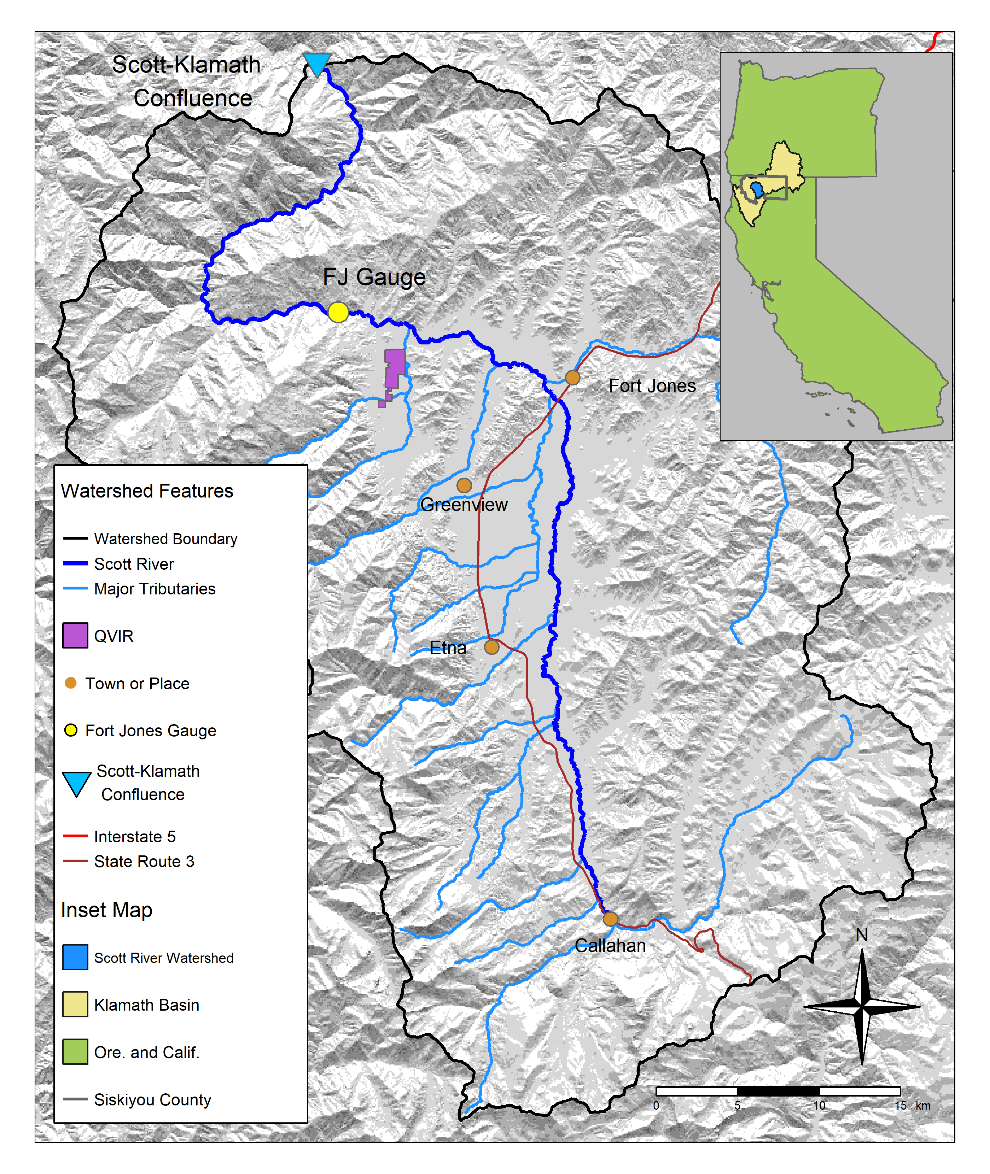

Figure 1: The Scott River watershed, with regional geographic context (see inset) and local features. Scott River flows generally from south to north and joins the Klamath after flowing through a steep canyon.

## 2.1 Scott River watershed setting and water use

### 2.1.1 Geography, climate and hydrology

The Scott River drains a 2,109 km2 (814 square mile) watershed known as Scott Valley, and is a major tributary to the Klamath River, which drains an area spanning sections of Northern California and Southern Oregon (Figure 1). Scott Valley has a Mediterranean climate with distinctive seasons of cool, wet winters and warm, dry summers. This seasonality in water input creates highly seasonal flow in the Scott River and tributary streams (Figure 2). The beginning of a water year therefore coincides with the late low flow season and immediately precedes the onset of first winter precipitation.

In most dry-to-average water years, sections of the Scott River become seasonally dewatered (NCRWQCB 2005; Figure 5 in Tolley, Foglia, and Harter 2019). This occurs when the elevation of the water table drops below the bottom of the river channel, as streams and groundwater are highly interconnected in the Scott River watershed. Tributary streams, particularly along their alluvial fan apeces, and the Scott River are sources of recharge to the aquifer (Mack 1958; Harter and Hines 2008). Groundwater discharge sustains streamflow in some areas, especially during the dry season of August through October or November (Tolley, Foglia, and Harter 2019).

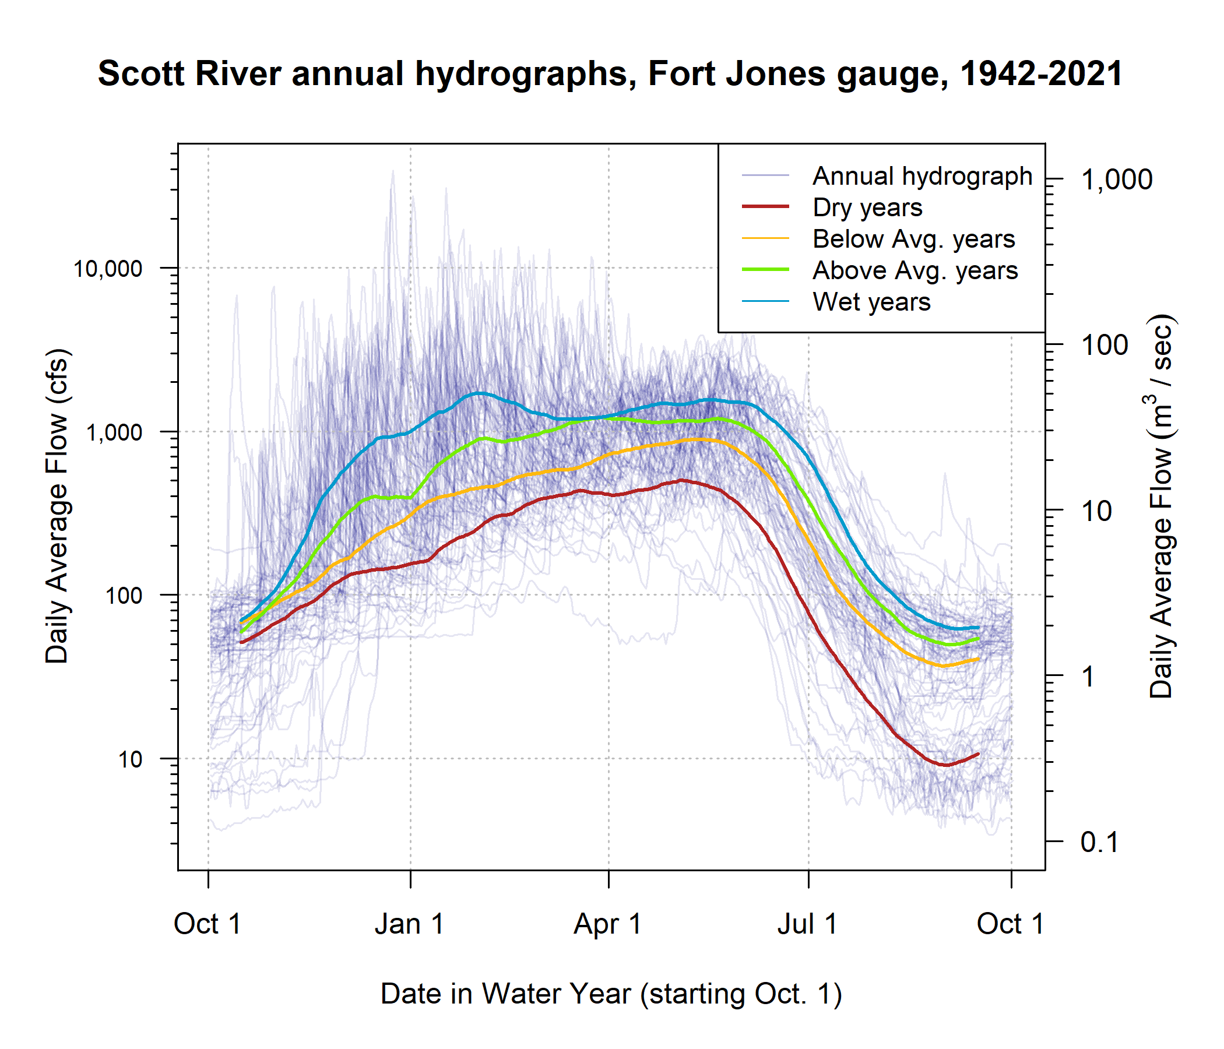

Figure 2: The Mediterranean climate produces highly seasonal flows in the Scott River. Each translucent line traces one annual hydrograph measured at the Fort Jones gauge, and the darker lines illustrate the 30-day smoothed median daily flow in Dry, Below Average, Above Average, and Wet water year types, for water years 1942-2021. The water year type is defined by quartiles of the distribution of total annual flow.

### 2.1.2 Water uses and management objectives

Water in Scott Valley is used for agricultural, domestic, and municipal supply. It also facilitates recreation and provides Native American cultural services, among other designated beneficial uses (NCRWQCB 2006). Because the watershed is undammed, managers and water users influence Scott River flow primarily via diversion of surface waters and pumping of groundwater. Consequently, the most powerful tool available to manage Scott River water flow is regulation of land use and thus water demand (Siskiyou County 2021).

Scott Valley is not a census-designated place and therefore does not have an official population estimate; however, census block-level population data, area-weighted according to the fraction of each block that overlaps with the watershed, indicate that in 2020 the population of the Scott River watershed was approximately 5,186 (U.S. Census Bureau 2021). Most reside outside the boundaries of the two incorporated towns Fort Jones and Etna, with estimated populations of 695 and 678, respectively (U.S. Census Bureau 2021).

Historically, local regulation of land use has focused on maintaining the rural and agricultural character of Scott Valley (Scott Valley Area Plan Committee 1980). Regulating land use to improve ecological outcomes would entail significant economic, political and social risks, because much of the economic activity in this area is related to agriculture. The primary crops grown in Scott Valley are pasture for cattle feed and alfalfa (Siskiyou County 2021). In addition to local economic impact, Scott River conditions influence fish population dynamics both within the watershed and in the broader Klamath system. The health of the Klamath salmon run has implications for commercial fishing, recreational activities, and cultural practices of Native American tribes in the region, including the Quartz Valley Indian Community and the Karuk and Yurok Tribes (Graham 2012).

All of the regulatory and management programs in this region, including recommended instream flows (CDFW 2017), recent emergency drought measures (SWRCB 2022), and legal rights governing surface water diversion (Superior Court of Siskiyou County 1980), are tabulated in units of cubic feet per second (cfs). For consistency, this document will also use primarily cfs units.

## 2.2 Species of concern: coho and Chinook salmon

This study intends to predict the hydrologic needs of two species, coho and Chinook salmon. To this end, we used several decades worth of hydrologic and ecological data collected in the Scott River watershed. Although both species need fall flows to migrate from the ocean to natal spawning streams, the life history strategies of these two salmonids are distinct in several ways, and consequently we anticipate some differences in the functional flows needed to sustain the two species.

### 2.2.1 Salmon management and monitoring in the Scott River watershed

Over the past three decades, several organizations and agencies have conducted extensive monitoring and published a series of reports and plans regarding the salmon fisheries in the Scott River watershed. In the 1990s, fall flows in the Scott River were reported to be too low in some years to allow for Chinook spawning in September-November (CRMP and SRWC 2000), but in the mid-2000s it was reported that low fall flows rarely affected the later (November-January) spawning runs of steelhead and coho salmon (SRWC 2005). More recently, fall flows have affected coho salmon as well as Chinook, as the late onset of winter storms has delayed coho spawning in some water years (e.g., CDFW 2015a). In the mid-2000s, a local conservation organization identified the lack of suitable summer and winter rearing habitat as a probable limitation on Scott River coho smolt production (SRWC and Siskiyou RCD 2005). Several years later, in a NOAA Fisheries Coho Recovery Plan, NMFS identified the juvenile life stage as the most limited in the population (NMFS 2014).

Monitoring activity in the past 20 years has included population estimates from a video counting flume and a rotary screw trap operated by CDFW (CDFW 2015b; Massie and Morrow 2020), and spawning surveys for Chinook (Siskiyou RCD 2015b, 2017b, 2018) and coho (Maurer 2003; Siskiyou RCD 2005, 2006, 2010, 2011, 2012, 2013, 2014, 2015a, 2017a; Quigley 2007). Recent management activity has included the leasing of surface water rights from landowners to enhance summer flows (e.g., SRWT 2018), the prioritization of stream reaches for habitat restoration (SRWC 2018), several pilot projects to construct and assess the impact of beaver dam analogs (BDAs) on aquatic habitat and fish populations (Yokel 2018), a coordinated rescue effort to relocate juvenile salmon that were cut off from outmigrating by disconnected river reaches (CDFW 2015a), and the development of long-term groundwater management plan by Siskiyou County and local stakeholders (Siskiyou County 2021).

### 2.2.2 Life cycle and status of coho salmon (*Oncorhynchus kisutch*)

Returning adult coho spawn in natal streams between November and January (Knechtle and Giudice 2020), and juvenile coho spend approximately one full year in freshwater streams before migrating to the ocean as smolts (Moyle 2002; McMahon 1983). In the Scott River system these natal streams are the tributaries along the margins of the valley floor (Siskiyou RCD 2004).

In previous studies, the strongest predictor of juvenile coho abundance in a stream system was spatial habitat (Bradford et al. 2016; Nickelson et al. 1992; Bustard and Narver 1975), although adequate food and cover were also important (McMahon 1983). The primary mechanism for spatial constraints on abundance appears to be that juvenile coho become more territorial as they grow (McMahon 1983).

An average coho life cycle is illustrated in Figure 3. Some coho salmon return to spawn at age 2 as grilse, but the majority (e.g., 92.4% in 2020) return after more than one year in the ocean, giving the Scott coho salmon run its characteristic 3-year cohort return interval (Knechtle and Giudice 2021).

Coho salmon in the Scott Valley are listed as threatened under the federal and California Endangered Species Acts (ESAs). They belong to the Southern Oregon / Northern California Coast (SONCC) Evolutionarily Significant Unit (ESU), which was listed as threatened under the federal and state ESAs in 1997 and 2005, respectively. State-wide, coho populations have declined more than 90% since the 1940s (Brown, Moyle, and Yoshiyama 1994).

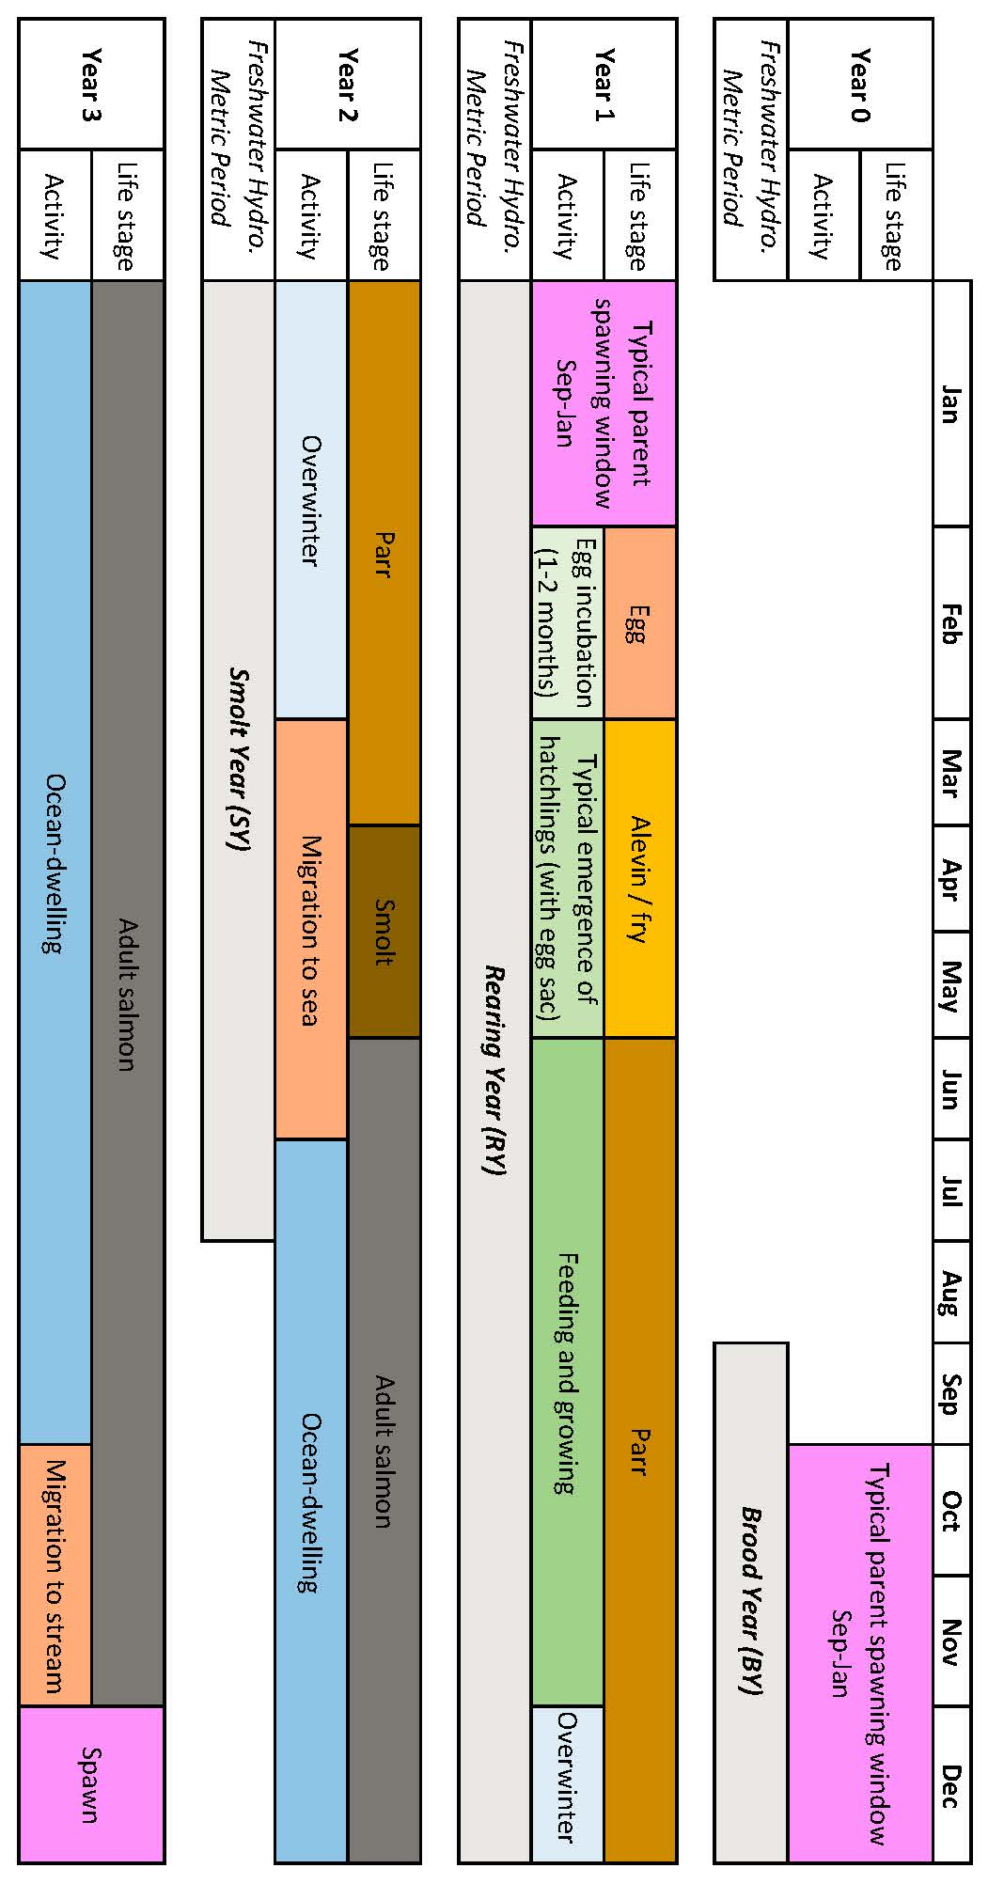

Figure 3: Typical life stage progression of coho salmon in the Scott River watershed.

### 2.2.3 Life cycle and status of Chinook salmon (*Onchorhynchus tsawytscha*)

Chinook salmon in the Scott Valley are a candidate for listing under the federal ESA, and are not listed under the California ESA. They belong to the Southern Oregon / Northern California Coast (SONCC) Evolutionarily Significant Unit (ESU).

Typically, adult Chinook salmon return to spawn in Scott Valley streams in the fall months September-December when flows are sufficient for salmon passage (Knechtle and Giudice 2020; Siskiyou RCD 2015a, 2017b). Chinook in this watershed hatch in the spring and migrate to the ocean in their first year of life (Agrawal et al. 2005). Chinook spend the majority of their life in the ocean, and return to their natal streams shortly before spawning (Healey 1991). However, substantial variability exists within this broader structure: Chinook salmon exhibit variation in multiple life stages, including time of seaward migration, age of maturity, and timing of return to natal stream (Healey 1991; Bourret, Caudill, and Keefer 2016). Consequently, a diagram of the Chinook life cycle would include more variability than the more structured coho life cycle reflected in Figure 3.

As recently as 2013, the SONCC Chinook population was stable and becoming more complex (Wainwright et al. 2013). However, in monitoring from 2015-2020, the number of returning adults (the escapement) was 65% below historical average, and the change in the Scott River Chinook population has been more rapid than the decline in the overall Klamath Basin Chinook run (CDFW 2021). Ocean conditions may have contributed to a broad decline in Chinook populations from Alaska to California (Welch, Porter, and Rechisky 2021). Some studies have found that the leading cause of declining Chinook populations are ocean conditions, including including temperature, upwelling currents and food resources (Hunt, Mulligan, and Komori 1999), while others have identified hatchery practices as the primary cause (Quiñones et al. 2014).

### 2.2.4 Relevant distinctions in Chinook and coho life histories

Chinook and coho salmon are distinct in several ways relevant to this study and to management considerations:

* In most years Chinook spawning migration takes place earlier (September-December) than coho (October-January).
* Chinook in this watershed hatch in the spring and migrate to the ocean in their first year of life, in contrast to coho, which spend a full year in the stream before migrating (Agrawal et al. 2005; Knechtle and Giudice 2020).
* Coho salmon prefer to spawn in reaches with smaller spawning gravels than Chinook salmon. Consequently the majority of coho redds are found in Scott River tributaries, while Chinook redds are more commonly found in the mainstem Scott River (e.g., Siskiyou RCD 2017b, 2017b).
* Declining populations of coho salmon have been noted in the Klamath basin and more broadly in coastal California streams since the 1990s (e.g., Brown, Moyle, and Yoshiyama 1994), while regional Chinook populations have historically been more robust (Wainwright et al. 2013). However, a declining trend was observed in the Klamath run of Chinook in the 2010s, and this trend was more significant in the Scott River system than the broader Klamath basin (Knechtle and Giudice 2021). These trends have prompted additional monitoring of Scott Valley Chinook in the past decade (e.g., spawning surveys such as Siskiyou RCD 2015b, 2017b).

# 3 Methods: Quantitative analysis

We used linear regression to assess the feasibility of predicting an ecological response using dozens of potential hydrologic predictor metrics. The objectives of the linear model selection exercise were to 1) empirically estimate which hydrologic flows were related to coho and Chinook reproductive outcomes and 2) assign weights of relative importance to develop a predictive Hydrologic Benefit formula, using slopes of the linear models.

## 3.1 Predictors: Flow metrics to describe Scott River flow regime

Hydrologic predictors consist of flow metrics calculated from the daily flow record at the Fort Jones river gauge from 1942-2021. The full suite of metrics is calculated on a water-year basis (i.e., each type of metric produces one value for each water year). All annual water metrics considered in this study are included in *Supplemental Table 1*. Abbreviations, relevant time periods and metric calculation details are listed in Table 1.

Firstly, a series of metrics from the catalog of California-specific functional flows (as illustrated in Figure 4) (Yarnell et al. 2020; Patterson et al. 2020) were selected to highlight the history and salient characteristics of the Scott River flow regime over the past eight decades. Additional information is available in Patterson et al. (2020) and supporting documentation. All selected functional flow metrics have some known ecological function or interpretation: Total annual flow is used to evaluate water year type. Phenomena measured with fall metrics, such as fall pulse magnitude and fall pulse timing, provide olfactory migration signals and spawning access to anadromous fish; however, a discrete fall pulse does not occur in every water year. Wet season metrics, such as wet season onset timing and baseflow magnitude, can be used to gauge conditions during egg incubation or the overwintering period for juvenile coho salmon. Spring metrics, such as spring flow recession rate of change, occur during the transition from wet to dry season, and indicate conditions during early juvenile salmon rearing as well as the flow available for outmigration from Scott Valley to the ocean. Finally, metrics like the duration and median flow of the dry season indicate the timing and severity of low-flow conditions in which spatial habitat is constrained and connectivity between reaches may be limited.

Secondly, we devised two additional metrics for this study area related to timing of anadromous fish access to preferred spawning habitat (illustrated in Figure 5). These metrics are referred to as “reconnection” and “disconnection” dates. They assume a flow threshold, defined at the Fort Jones gauge, that corresponds to a certain degree of “connectivity” in the Scott River stream system. The date on which this connectivity is lost in the spring/summer or gained in the fall has implications for whether salmon passage exists during the preferred migrating time window. These metrics are related to the California-specific functional flows, namely, the timing and slope of spring recess and the timing of a fall pulse flow 1. More importantly, they add value to this analysis because of their direct relation to fish passage in the watershed.

A discrete number of thresholds were selected from the continuum of flows, ranging between a lowest value of 10 cfs and highest value of 100 cfs. At the lowest value all tributaries are known to be disconnected and significant dry reaches exist along the main stem (Tolley, Foglia, and Harter 2019). At the highest value, most tributaries connect with the mainstem and the mainstem Scott River is flowing contiguously, including the “tailings” section, a boulder sediment substrata section of the mainstem that is most susceptible to falling dry (Tolley, Foglia, and Harter 2019; Siskiyou County Flood Control and Water Conservation District 2021).

The reconnection timing of proximate flow thresholds is somewhat correlated. It was therefore necessary to reduce the number of flow thresholds under consideration in the linear model selection process to a) identify flow thresholds with the greatest impact on salmon reproduction (to the extent possible with such a small dataset), and b) avoid the inclusion of redundant hydrologic information (Olden and Poff 2003). To identify the threshold(s) with the highest predictive power and potentially the lowest redundancy, we examined relationships between reconnection dates and biological monitoring data.

Table 1: Explanation of time period definitions and hydrologic metrics used in this analysis. Each type of metric, for each threshold value (e.g., 100 cfs or 50th flow percentile), produces one value per water year.

| Abbrev. | Full Name | Thresholds | Description |
| --- | --- | --- | --- |
| BY | Brood Year | -- | September-December window in which spawning occurs (by the parents of the designated cohort). |
| RY | Rearing Year | -- | January-December window during which a cohort hatches and rears in freshwater. |
| SY | Smolt Year | -- | January-July window during which a cohort grows in freshwater and outmigrates to the ocean. |
| CFLP | Coho Freshwater Life Period | -- | The (conservatively wide) 21-month window, September through July, in which members of a cohort or the cohort's spawning parents are present in the freshwater system. |
| recon | River Reconnection Day (for a given life stage and threshold) | 10, 15, 20, 50, 80, and 100 cfs | The day, usually in the fall, on which the Scott River gains a certain degree of connectivity. Defined as the first day on which FJ Gauge flow rises above a designated threshold (e.g., 10 cfs) (units of days after Aug. 31). Assigned to a salmon lifestage using abbreviations such as RY (Rearing Year). Example: RY_recon_10 |
| discon | River Disconnection Day (for a given life stage and threshold) | 10, 15, 20, 50, 80, and 100 cfs | The day, usually in the spring or early summer, on which the Scott River loses a certain degree of connectivity. Defined as the first day on which FJ Gauge flow drops below a designated threshold (e.g., 100 cfs) (units of days after Aug. 31). Assigned to a salmon lifestage using abbreviations such as BY (Brood Year). Example: BY_discon_100 |
| min_flow | Minimum Flow | -- | Minimum average daily flowrate recorded in the relevant period. Months of the designated time period (e.g. Sep-Dec for BY) are added to the column name for clarity. Example: BY_min_flow_sepdec |
| tot_flow | Total Flow | -- | Sum of all daily flow volumes recorded in the relevant period. Months of the designated time period (e.g. Jan-Jul for SY) are added to the column name for clarity. Example: SY_tot_flow_janjul |
| FA_Mag | Fall Pulse Magnitude | -- | Peak magnitude of fall pulse event (maximum daily peak flow during event) (cfs) in relevant lifestage. Example: RY_FA_Mag |
| FA_Tim | Fall Pulse Timing | -- | Start date of fall pulse event in water year days |
| FA_Dur | Fall Pulse Duration | -- | Duration (# of days) of the fall pulse event |
| Wet_BFL_Mag | Wet Season Baseflow Magnitude | Median (50th daily flow percentile) | The magnitude of the median rate of baseflow (i.e., non-storm flow) during the wet season. Abbreviation: Wet_BFL_Mag_50 |
| Wet_Tim | Wet Season Onset Timing | -- | Start date of wet-season in water year days |
| Wet_BFL_Dur | Wet Season Baseflow Duration | -- | Wet-season baseflow duration (# of days from start of wet-season to start of spring season) |
| SP_Tim | Spring Onset Timing | -- | Start date of spring in water year days |
| SP_ROC | Spring Recession Rate of Change | -- | Spring flow recession rate (median daily rate of change over decreasing periods during the recession) |
| DS_Mag | Dry Season Flow Magnitude | 50th and 90th flow percentile | Percentile of daily flow within dry season |
| DS_Tim | Dry Season Onset Timing | -- | Dry-season baseflow start timing (water year day of dry season) |
| DS_Dur_WS | Dry Season Duration | -- | Dry-season baseflow duration (# of days from start of dry season to start of wet season) |
|  |  |  |  |

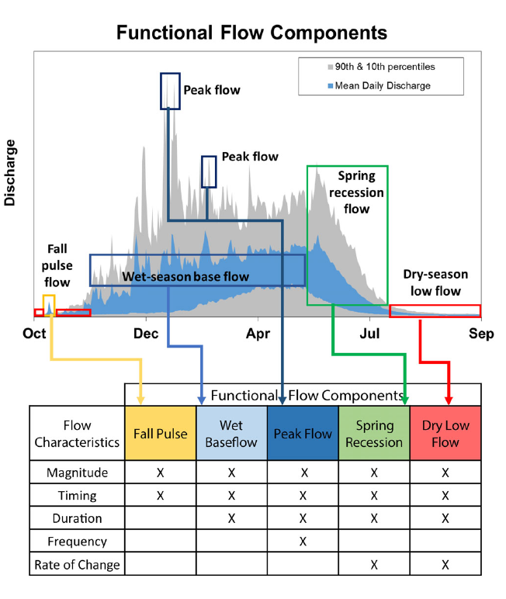

Figure 4: Figure 2 from Yarnell et al., 2020. Illustration of five functional flow categories identified for a mixed rain-snowmelt runoff river in California.

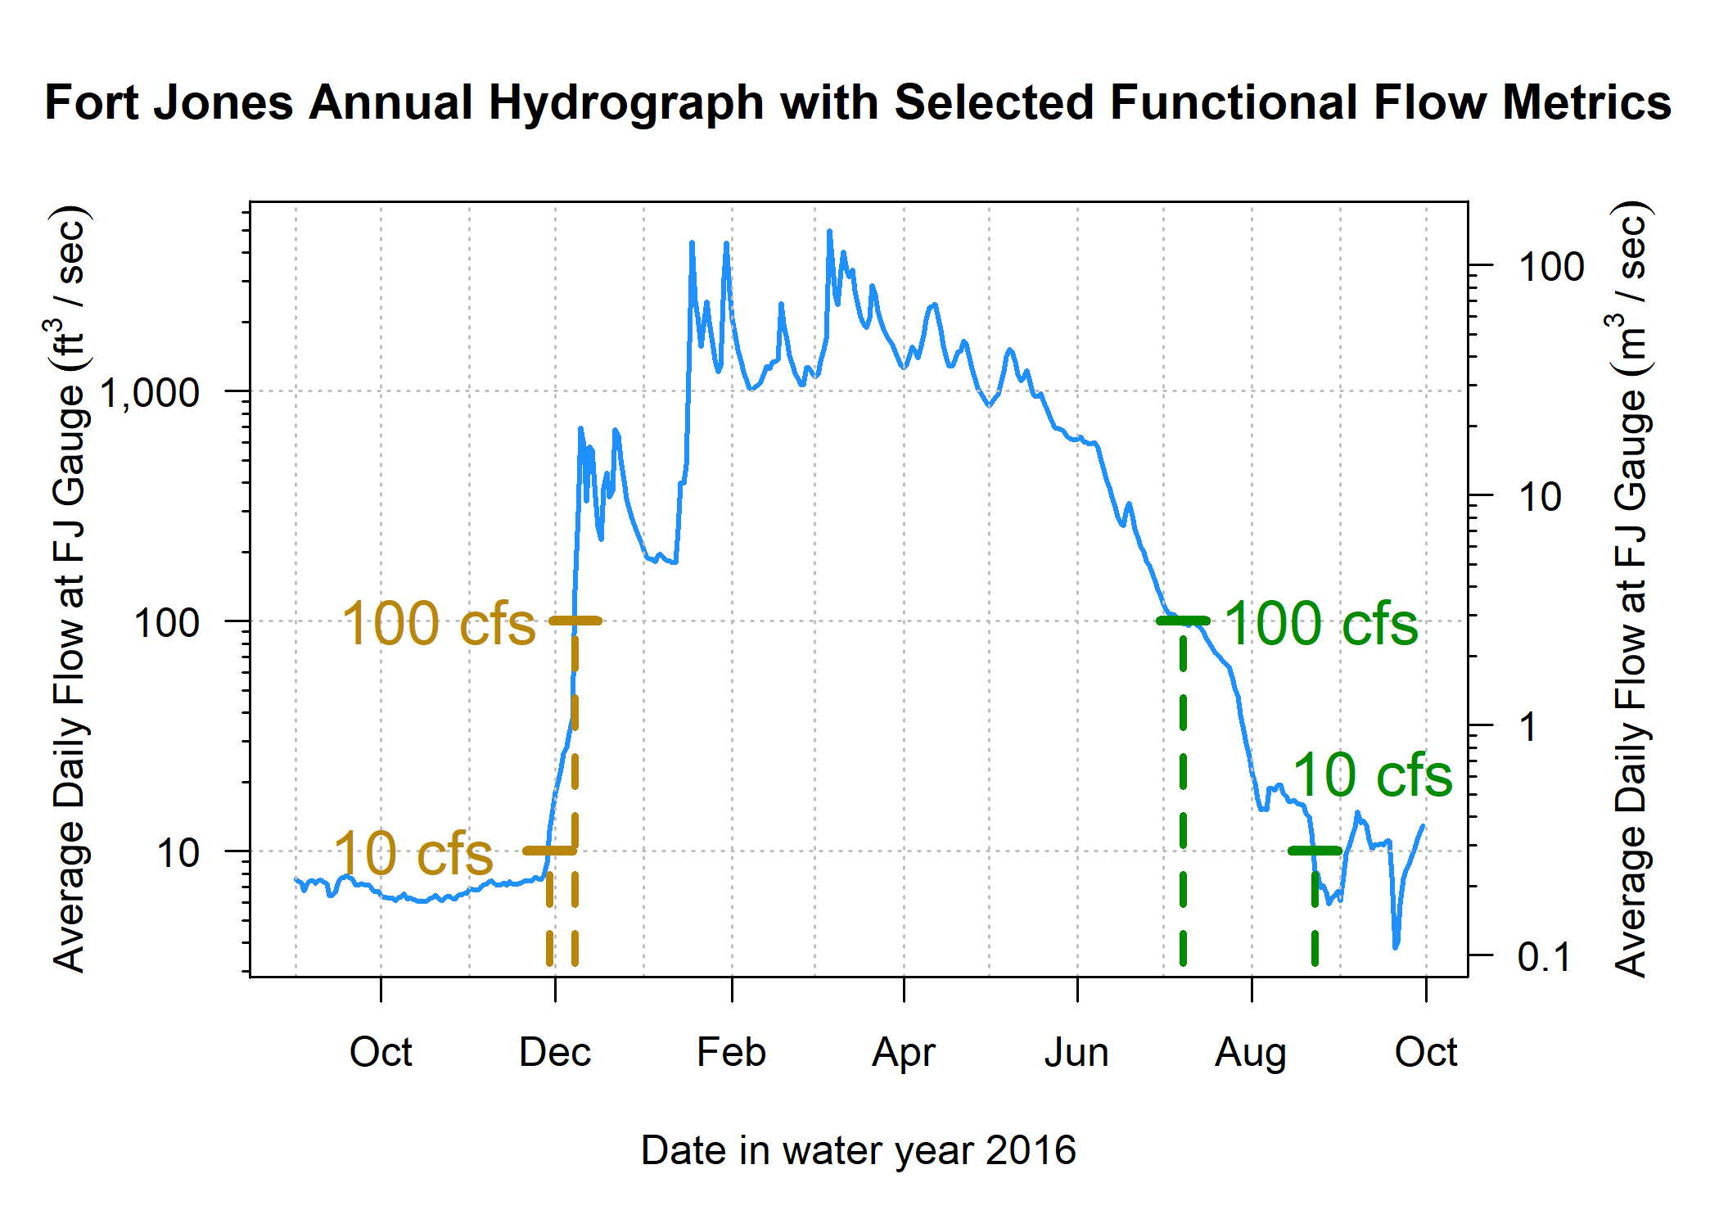

Figure 5: Reconnection and disconnection dates are highlighted for one water year. Two example thresholds, 10 and 100 cfs (0.28 and 2.8 cms, respectively) are highlighted, which correspond to distinct river connectivity (and salmon habitat access) conditions in the Scott River watershed as observed at the Fort Jones gauge (see Results for more detail on selection of flow thresholds).

## 3.2 Response: Ecological monitoring data

Multiple observed quantities were evaluated as candidates to best represent the ecological response in the flow-ecology relationship.

Factors influencing the population size of anadromous fish include ocean conditions and freshwater conditions. In this study, because we are interested only in the conditions in their natal streams, we have focused on fish population metrics that are influenced by the freshwater system. The key ecological observations used in this study are:

1. Number of adults migrating from the ocean to freshwater natal streams to spawn. This quantity, the ‘escapement’, is measured at a CDFW counting facility, using a resistance board weir and video counting flume in the Scott River (e.g., Knechtle and Giudice 2021).
2. Number of salmon gravel nests, or redds, observed during spawning window (e.g., Siskiyou RCD 2017a).
3. Number of juvenile yearling, or smolt, salmon. Smolt are counted as outmigrants, often from rotary screw trap observations (e.g., Massie and Morrow 2020).
4. In addition to these three metrics, we calculate a combined metric that normalizes for the annual escapement using monitoring data across multiple years to capture both the spawning and outmigrating events for the relevant cohort: the number of coho smolt produced per spawning female (coho spf) and the Chinook juvenile per adult metric (Chinook jpa).

## 3.3 Data alignment and correlation coefficients

A water year is a useful time unit for water managers and a common unit used in decision-support tools. However, a cohort of, e.g., coho salmon experiences conditions during multiple water years while residing in their spawning habitat. For coho salmon the life cycle is largely regular in Scott Valley, with 3 defined cohorts in which the vast majority of individuals return to natal streams at 3 years of age (e.g., CDFW 2021). Conversely, the majority of Chinook salmon return to spawn when they are 2 to 6 years old (Bourret, Caudill, and Keefer 2016), resulting in less of a cohort structure than for coho. Here we define the alignment (i.e., mapping) of a specific generation of fish (ecological outcome) with hydrologic metrics (predictors) observed across the portion of their life cycle spent in the Scott River system (*Supplemental Table 2*).

### 3.3.1 Data alignment - coho

The relevant unit of time for identifying the impacts of freshwater hydrology on a coho salmon cohort is defined here as a Coho Freshwater Life Period (CFLP), a duration of 21 months beginning the September of the year their parents spawned and ending the July of their outmigration from the watershed as smolts. This time period is conservatively wide; most spawning occurs in October or later, and most outmigration occurs in June or earlier (Moyle 2002), but the September-July duration was chosen to capture critical life stages even in extreme water years.

For convenience in referring to hydrologic metrics in different water years, this Coho Freshwater Life Period has been broken up into three subperiods (as shown in Figure 3 and described in Table 1):

* Brood Year (BY), September-December of the year of the cohort’s parents’ spawning
* Rearing Year (RY), January-December of the full year the cohort spends in the watershed
* Smolt Year (SY), January-July of the year of the cohort’s smolt outmigration

Coho Freshwater Life Periods overlap, e.g., the fall pulse flows in water year take place during one cohort’s Brood Year, and the same fall flows occur during the end of the Rearing Year for the cohort born in water year . In some rare cases, flow metrics may fall outside their designated subperiods (e.g., the extreme dry water year of 2014, in which the “fall reconnection” of flows in Brood Year 2013 did not occur until February of the cohort’s Rearing Year). Nonetheless, for consistency, even a January or February reconnection date will be referred to by the previous fall year designation.

To build empirical relationships between hydrology and biology, ecological response variables were indexed by Brood Year of the affected cohort and hydrologic metrics tabulated accordingly (*Supplemental Table 2*). For example, the value for fall reconnection timing (100 cfs flow threshold) in fall of 2011 was assigned to the column “BY_recon_100” for the Brood Year 2011 cohort. The same value was assigned to the column “RY_recon_100” for the Brood Year 2010, which experienced fall 2011 as rearing juveniles.

Each brood year is associated with multiple ecological response variable, i.e., “fish outcome” observation types, including number of Chinook and coho spawners observed and the estimated number of smolt observed at the end of their CFLP. Data were available and compiled for brood years 2004 through 2019.

### 3.3.2 Data alignment - Chinook

Because Chinook migrate to the ocean in their first year of life, the duration of freshwater residence for each Chinook cohort is shorter than for coho, ranging from fall spawning to the subsequent spring or summer. Thus, only metrics from the Brood Year and from the Rearing Year wet season, spring recession and dry season were considered for Chinook predictions.

## 3.4 Predicting ecological outcomes for the species of concern

### 3.4.1 Correlation analysis - ecological metric selection

With hydrologic metrics assigned to each salmon generation, indexed by brood-year and corresponding smolt year (*Supplemental Table 2*), we assessed the potential for hydrologic metrics to predict biological outcomes by calculating Pearson correlation coefficients (**Pearson1895?**) between 49 hydrologic predictors and 7 ecological metrics (4 four for coho and three for Chinook) (*Supplemental Figure 1*). The ecological variable most correlated hydrologic metrics was selected for further statistical model development.

### 3.4.2 Linear modeling and model performance assessment

We used the R programming environment (R Core Team 2020) and the linear modeling function lm() (**Chambers1992?**) to build a complete set of two-predictor linear regression models of the selected ecological response variable, using the set of hydrologic predictor variables described above:

A complete set of one-predictor models () was also produced for comparative purposes. Linear models with more than two predictors were not evaluated; with a dataset this small, the risk of overfitting such higher order linear models would be relatively high (James et al. 2013).

Criteria used to evaluate model performance included degree of variability explained by the predictors ( and adjusted ), statistical significance (p-value and F-statistic), and the amount of total non-correlated information contained in the set of predictors (corrected AIC, or AICc, a statistic used for small sample sizes).

For each of the one-and two-predictor models, we calculated the estimated average model error using leave-one-out cross-validation (LOOCV; Table 3). In the LOOCV method, for a dataset with observations, the LOOCV error of a predictive model is obtained by recalculating the model coefficients times, each time leaving out one observation, and comparing the resulting prediction to the single left-out observation. The root mean square of these errors is the LOOCV error used to evaluate model performance in Results.

Finally, minimum performance criteria were established to select the models which were incorporated into the ultimate HB function (discussed further in Results).

### 3.4.3 Hydrologic Benefit formulation

The best performing linear models were selected (see below) and combined into an average ensemble model that comprises the “hydrologic benefit (HB) function”, in units of the ecological response variable:

We note that ecological outcome in water year is obtained for BY = wy - 1 for both salmon species.

An ensemble average model approach is necessary for the HB function to dampen the possible sensitivity of any individual linear model to a single water-year outcome. This approach avoids over-interpretation of results given the small ecological dataset.

### 3.4.4 Hydrologic Benefit Function sensitivity

To further explore the uncertainty associated with such a small dataset, the sensitivity of the predictive model was estimated by adding an additional data point. Specifically, a hypothetical value of “observed” coho spf was assigned to brood year 2015 (influenced by conditions in water year 2016). This is a missing value in the existing observational dataset. The missing value for brood year 2015 was replaced by 0, as well as the minimum, mean and maximum values of observed coho spf (5.8, 60.0, and 101.8 coho spf, respectively). The ensemble average coefficients in the HB function were recalculated based on each revised dataset. This sensitivity analysis was not implemented for Chinook (see Results).

# 4 Results

## 4.1 Flow history of the Scott River, described in functional flow metrics

Diagnostic metrics of Scott River flow have demonstrated clear trends over the past 8 decades. Between 1942 and 2021, total annual flow measured at the Fort Jones gauge has dropped from an average of approximately 600 to 400 thousand acre-feet (TAF, or from >800 to <600 million m3) (Figure 6, panel A). Ecosystem functional flow metrics, calculated with signal-processing techniques (Patterson et al. 2020) (illustrated in Figure 4), also show clear trends over time (Figure 6, panels B-H). The fall pulse onset date has trended slightly later (though a distinct fall pulse flow does not occur every year), and the magnitude of the fall pulse flows has decreased. The onset of the wet season has trended slightly later, though wet season median baseflows (i.e., flows not occurring during storm pulses) have remained stable on average (with a very slight downward trend). The rate of flow reduction during the spring has increased over time (i.e., the spring recession curve has grown steeper). The median dry season flow has dropped by approximately 50%, the onset of the dry season is earlier, and the duration of the dry season has increased (Figure 6).

The reconnection and disconnection dates also show trends over time. As a result, the wet season has notably narrowed over time with (approximate) fall onset trending later and the spring flow recession trending to begin earlier (Figure 7).

In aggregate over the past 80 years, these metrics show an increasing prevalence of unfavorable hydrologic conditions for salmonids, in terms of the flows needed during critical life stages. The primary causes of this reduced ecological functionality are a changing climate (especially a reduced snowpack and earlier snowmelt) and long-term changes in local consumptive water uses (Drake, Tate, and Carlson 2000; Van Kirk and Naman 2008; Foglia et al. 2013).

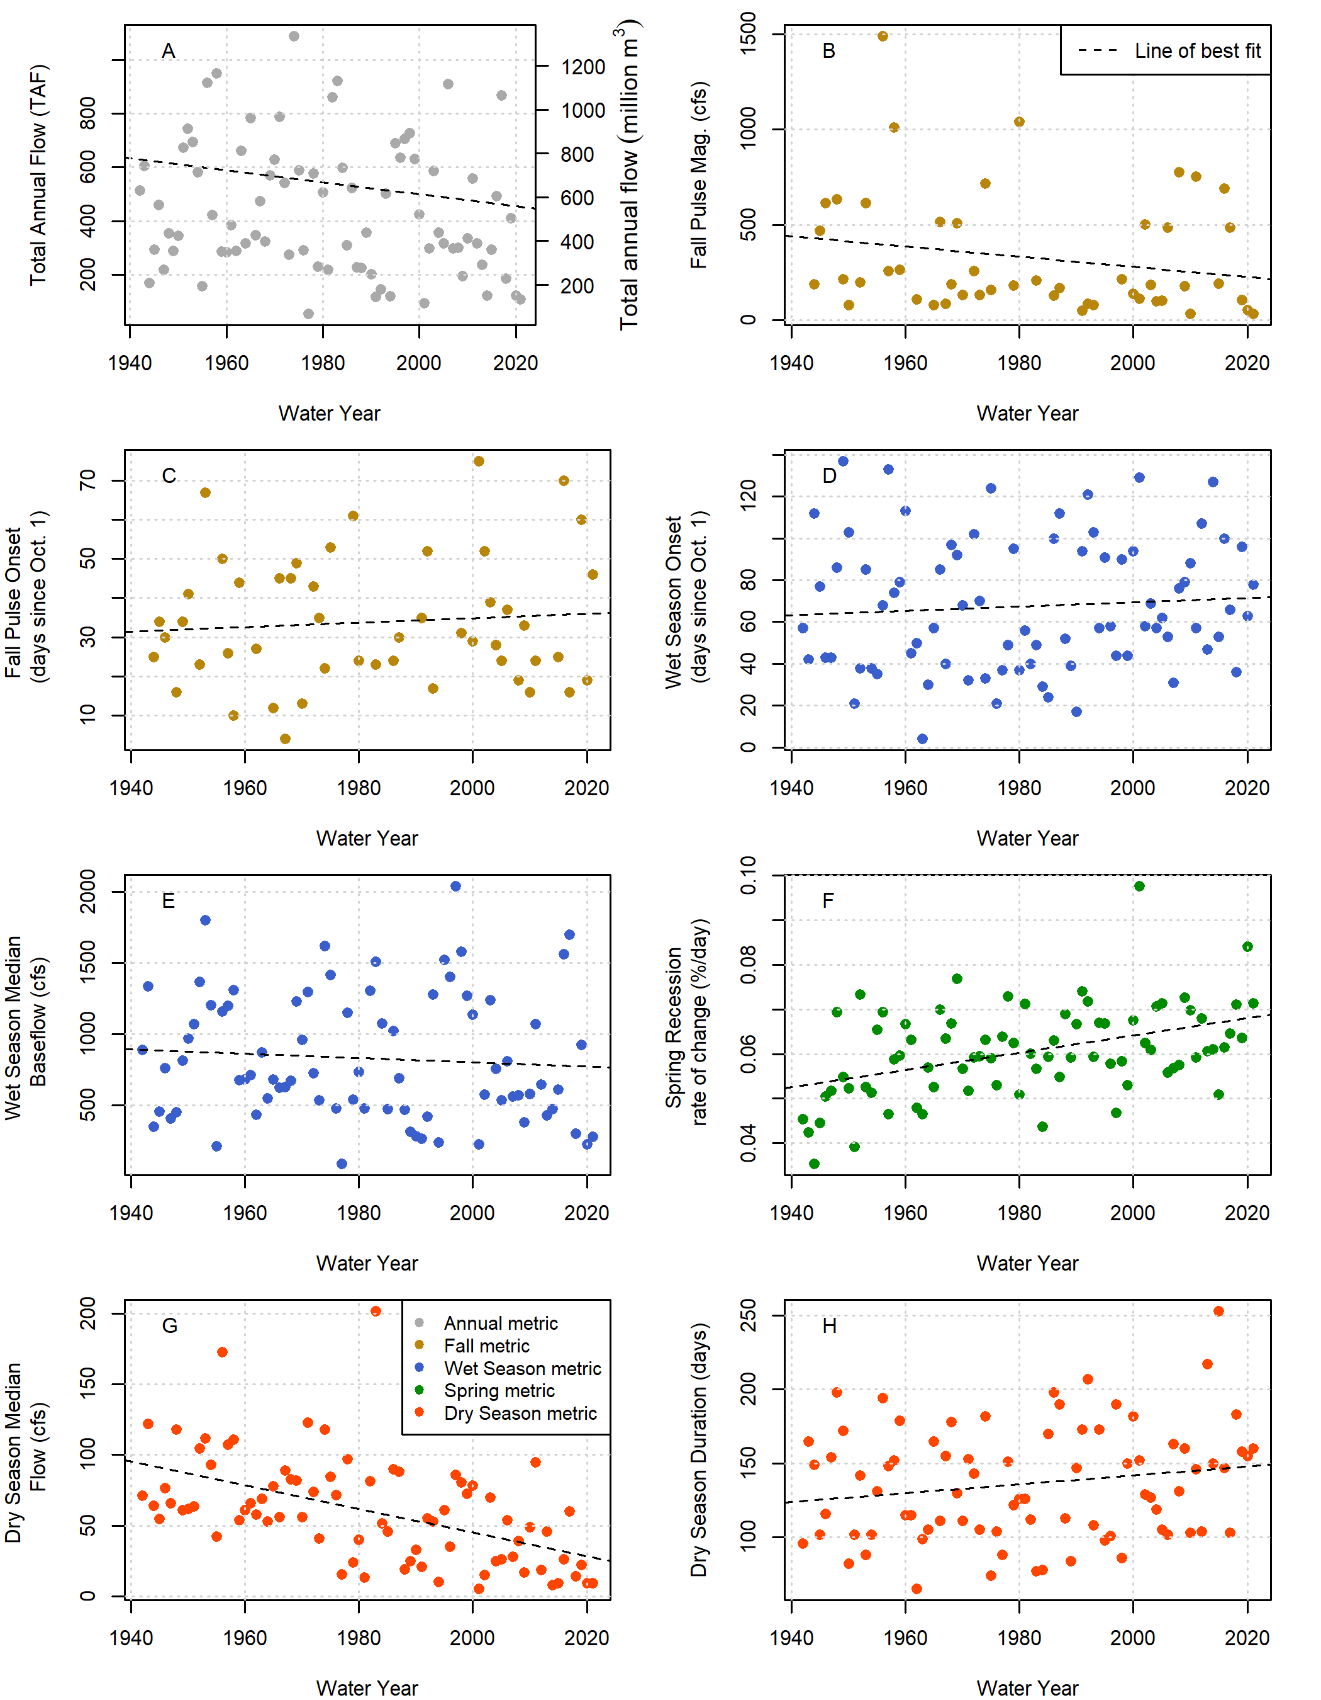

Figure 6: Total annual flow volume (panel A) and functional flow metrics (panels B-H; Patterson et al. 2020), derived from daily average flow measurements at the Fort Jones USGS flow gauge (ID 11519500) for water years 1942-2021.

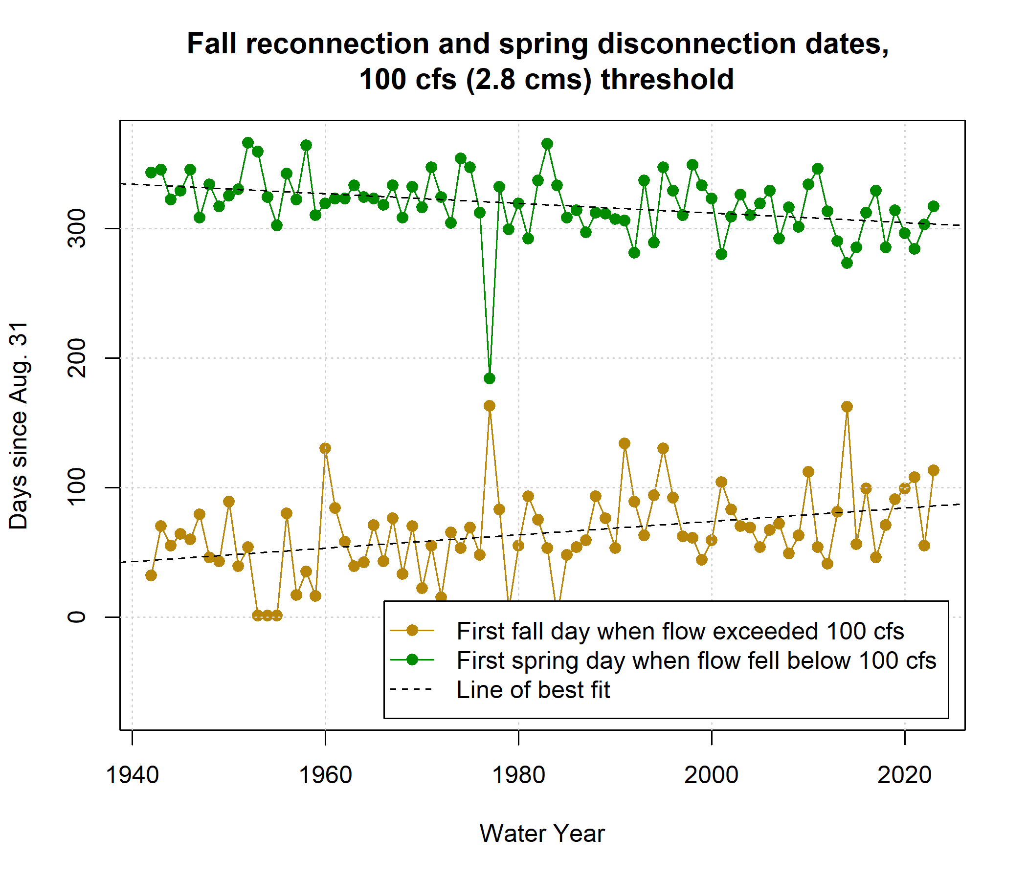

Figure 7: Disconnection and reconnection dates for the 100 cfs (2.8 cms) flow threshold, water years 1942-2021. The disconnection date refers to the first day in the spring on which flow drops below the designated threshold (100 cfs); the reconnection date refers to the first date in the fall on which flow rises above the designated threshold. Trends over the past 80 years suggest that the spring flow recession is trending earlier, and the fall river reconnection is trending later.

## 4.2 Metric selection and utility

### 4.2.1 Selection of ecological response variable: coho and Chinook outcome metrics

Correlation coefficients were used to select the ecological response variable for each species: coho smolts per female spawner (coho spf) and Chinook juveniles per adult (jpa).

In the correlation analysis we assessed relatedness of ecological outcome metrics with both types of hydrologic metric (reconnection/disconnection and functional flows). Degree of correlation was evaluated broadly: a threshold of (Figure 8) was selected to identify the best candidates among those available, even if it does not denote particularly strong predictive power on its own.

For coho salmon, the smolt per female spawner (coho spf) metric is negatively correlated with BY_recon at all thresholds. To a lesser degree, it is positively correlated with RY_discon at all thresholds, and negatively correlated with RY_recon at all thresholds but one. Among functional flow metrics, coho spf was positively correlated (with ) with the log of total Brood Year flow and the duration of the Rearing Year wet season. Coho spf was negativey correlated (with ) with the Rearing Year wet season onset timing. Fall pulse metrics also yielded several correlations, but these were excluded from the linear modeling exercise due to insufficient sample size. These correlations support the current scientific understanding that earlier fall reconnection in the fall and later disconnection in the spring/summer are related to higher relative fish production, or, more fundamentally, that wet years produce good conditions for coho spawning and rearing.

Of the ecological response variables that were evaluated for coho, the coho spf variable clearly showed a higher degree of correlation with hydrologic metrics than other ecological outcome variables. One reason for this metric outperforming the other three (coho salmon spawner abundance, juvenile abundance and number of observed redds) may be that the normalization to the number of spawners makes the three cohorts more comparable, as the spawner cohort size is quite variable amonge the three 3-year cohort generations, but also between generations of the same cohort. This normalized metric has also been identified by state agency analysts as indicative of freshwater ecosystem conditions at coho salmon populations below carrying capacity (CDFW 2021). Consequently, we focus the remainder of the hydro-ecological modeling analysis for coho uses the coho smolt per female (coho spf) metric as response variable.

For Chinook, conversely, none of the three available ecological response variables stood out as being substantially more correlated with hydrologic metrics than the others (*Supplemental Figure 1*). Furthermore, they all appeared less correlated with the hydrology than the coho variable, i.e., the coho-hydrology correlations, for the same set of predictor variables, generated more than did correlations between Chinook and hydrology. To be consistent with the coho spf, the Chinook juvenile per adult metric (Chinook jpa) was retained for linear modeling.

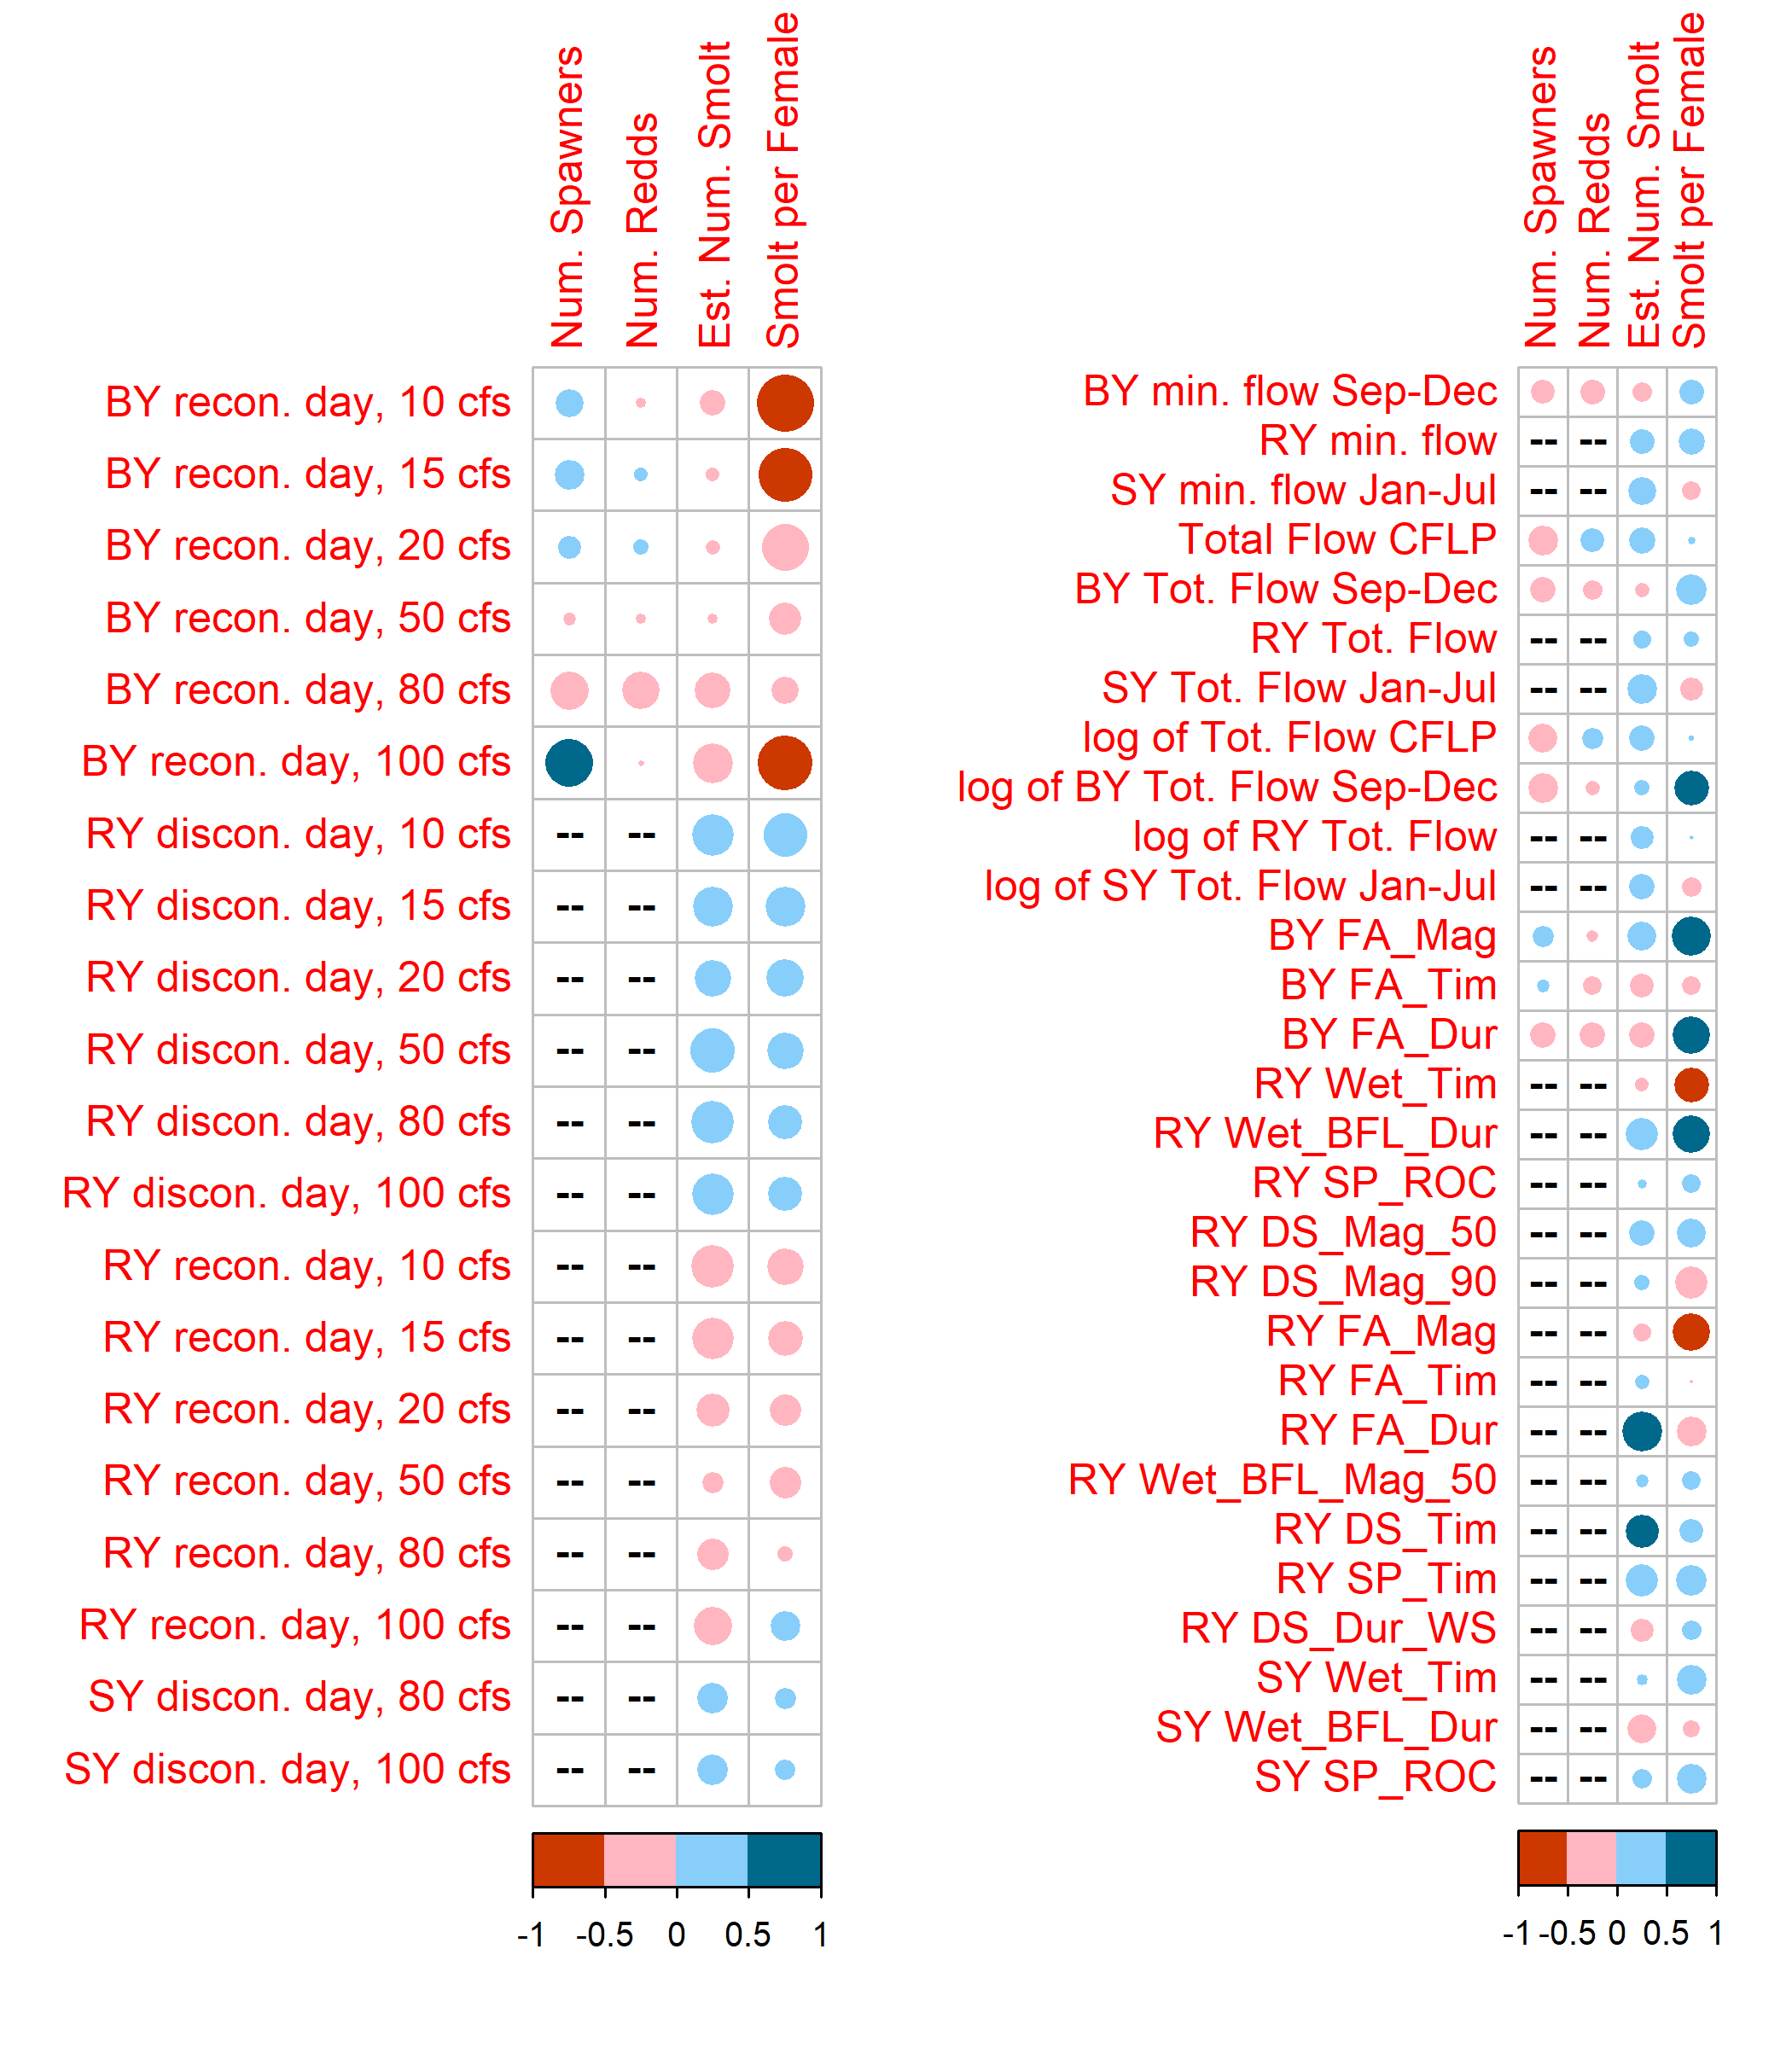

Figure 8: Correlations between 41 predictors and 4 coho monitoring metrics. Red colors indicate a negative correlation and blue colors indicate a positive correlation; the size and color of the circle in each box are both scaled to the value of the correlation coefficient. Large blue circles indicate that the quantity (such as the Brood Year fall pulse magnitude, or BY FA_Mag) is positively correlated with observed fish metrics; for dates, a blue dot indicates that a later date is correlated with higher fish values, while a red dot indicates that an earlier dot is correlated with higher fish values.

### 4.2.2 Selection of thresholds for fall reconnection dates

As mentioned in Methods, we examined relationships between reconnection dates and biological monitoring data in order to identify the flow threshold(s) with the highest predictive power and potentially the lowest redundancy. Relationships between the Brood Year reconnection dates for six flow thresholds and coho spf are shown in Figure 9. The trends in slope value and suggest that the date of crossing lower flow thresholds such as 10 and 15 cfs has greater biological significance than the date of crossing thresholds like 40 cfs, with 20 cfs being somewhat intermediate. In the context of this watershed, it suggests that a Fort Jones gauge flowrate of 10 cfs is a critical threshold for coho passage into the mainstem Scott River.

For Chinook, no significant relationships were obtained between the three ecological observation types and the Brood Year reconnection dates (i.e., no values exceeded 0.1).

It should be noted that for this metric, at very low flows like 8 and 10 cfs, a data censoring problem emerges, as the flow never drops below the threshold in some years. “Reconnection” as flows rise above that threshold cannot occur in such years. For these water years, the date of September 1st was selected as the “threshold crossing day”. This is considered to represent the earliest date that a spawning coho salmon would require spawning flows measurable at the Fort Jones gauge. Thus, in average and wet years (and, in the mid-20th century, most years) the distribution of values for this threshold-exceeding date for low flowrates would be heavily skewed to September 1st. This data processing method retains the information that the flow in a high-baseflow year may have served the spawning needs of the salmon, but conveys no other information about flow timing.

At reconnection dates for 100 cfs, the of the relationship is higher than at 40 cfs. In previous monitoring, a Fort Jones gauge flowrate of 100 cfs has corresponded with the reconnection of a key river reach impacted by mine tailings, allowing coho passage to favorable tributary stream habitat upstream of this reach (*pers. comm.*, Sommarstrom 2020). The relatively high value between the 100 cfs Brood Year reconnection date and coho spf (0.434) suggests that earlier access to this additional habitat improves watershed-wide reproductive outcomes.

Using only the two models with the highest , we selected the reconnection and disconnection date flow thresholds of 10 cfs and 100 cfs for further analysis (Figure 9). This decision could be revisited if additional years of data become available.

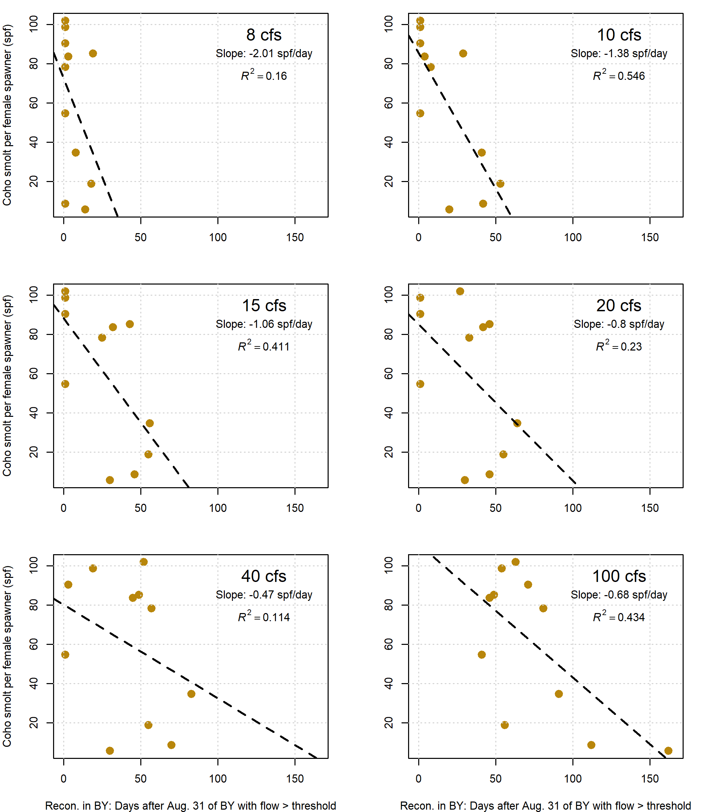

Figure 9: Correlations between the ‘reconnection’ dates, or dates of fall flow rising above the designated flow threshold, for six flowrates. X-axis units are days after Aug. 31 of the coho salmon cohort Birth Year.

## 4.3 Linear modeling

We used all hydrologic predictors to generate the set of all possible 1- and 2-predictor linear models of the relative reproduction for Chinook (Chinook jpa) and coho (coho spf) salmon. Coho reproduction rates appear to be correlated with some hydrologic metrics, based on the hydrologic conditions and coho observations in brood years 2004 - 2019, corresponding to water years 2007-2020. Relative reproduction in Chinook was less predictable than in coho, using the same set of hydrologic predictors: for Chinook, maximum values were 0.2 and 0.5 for single- and two-predictor models, respectively, while for coho they were 0.5 and 0.9 (Figure 10). Given the limited strength of the Chinook data, the development of the HB function was conducted only for coho salmon.

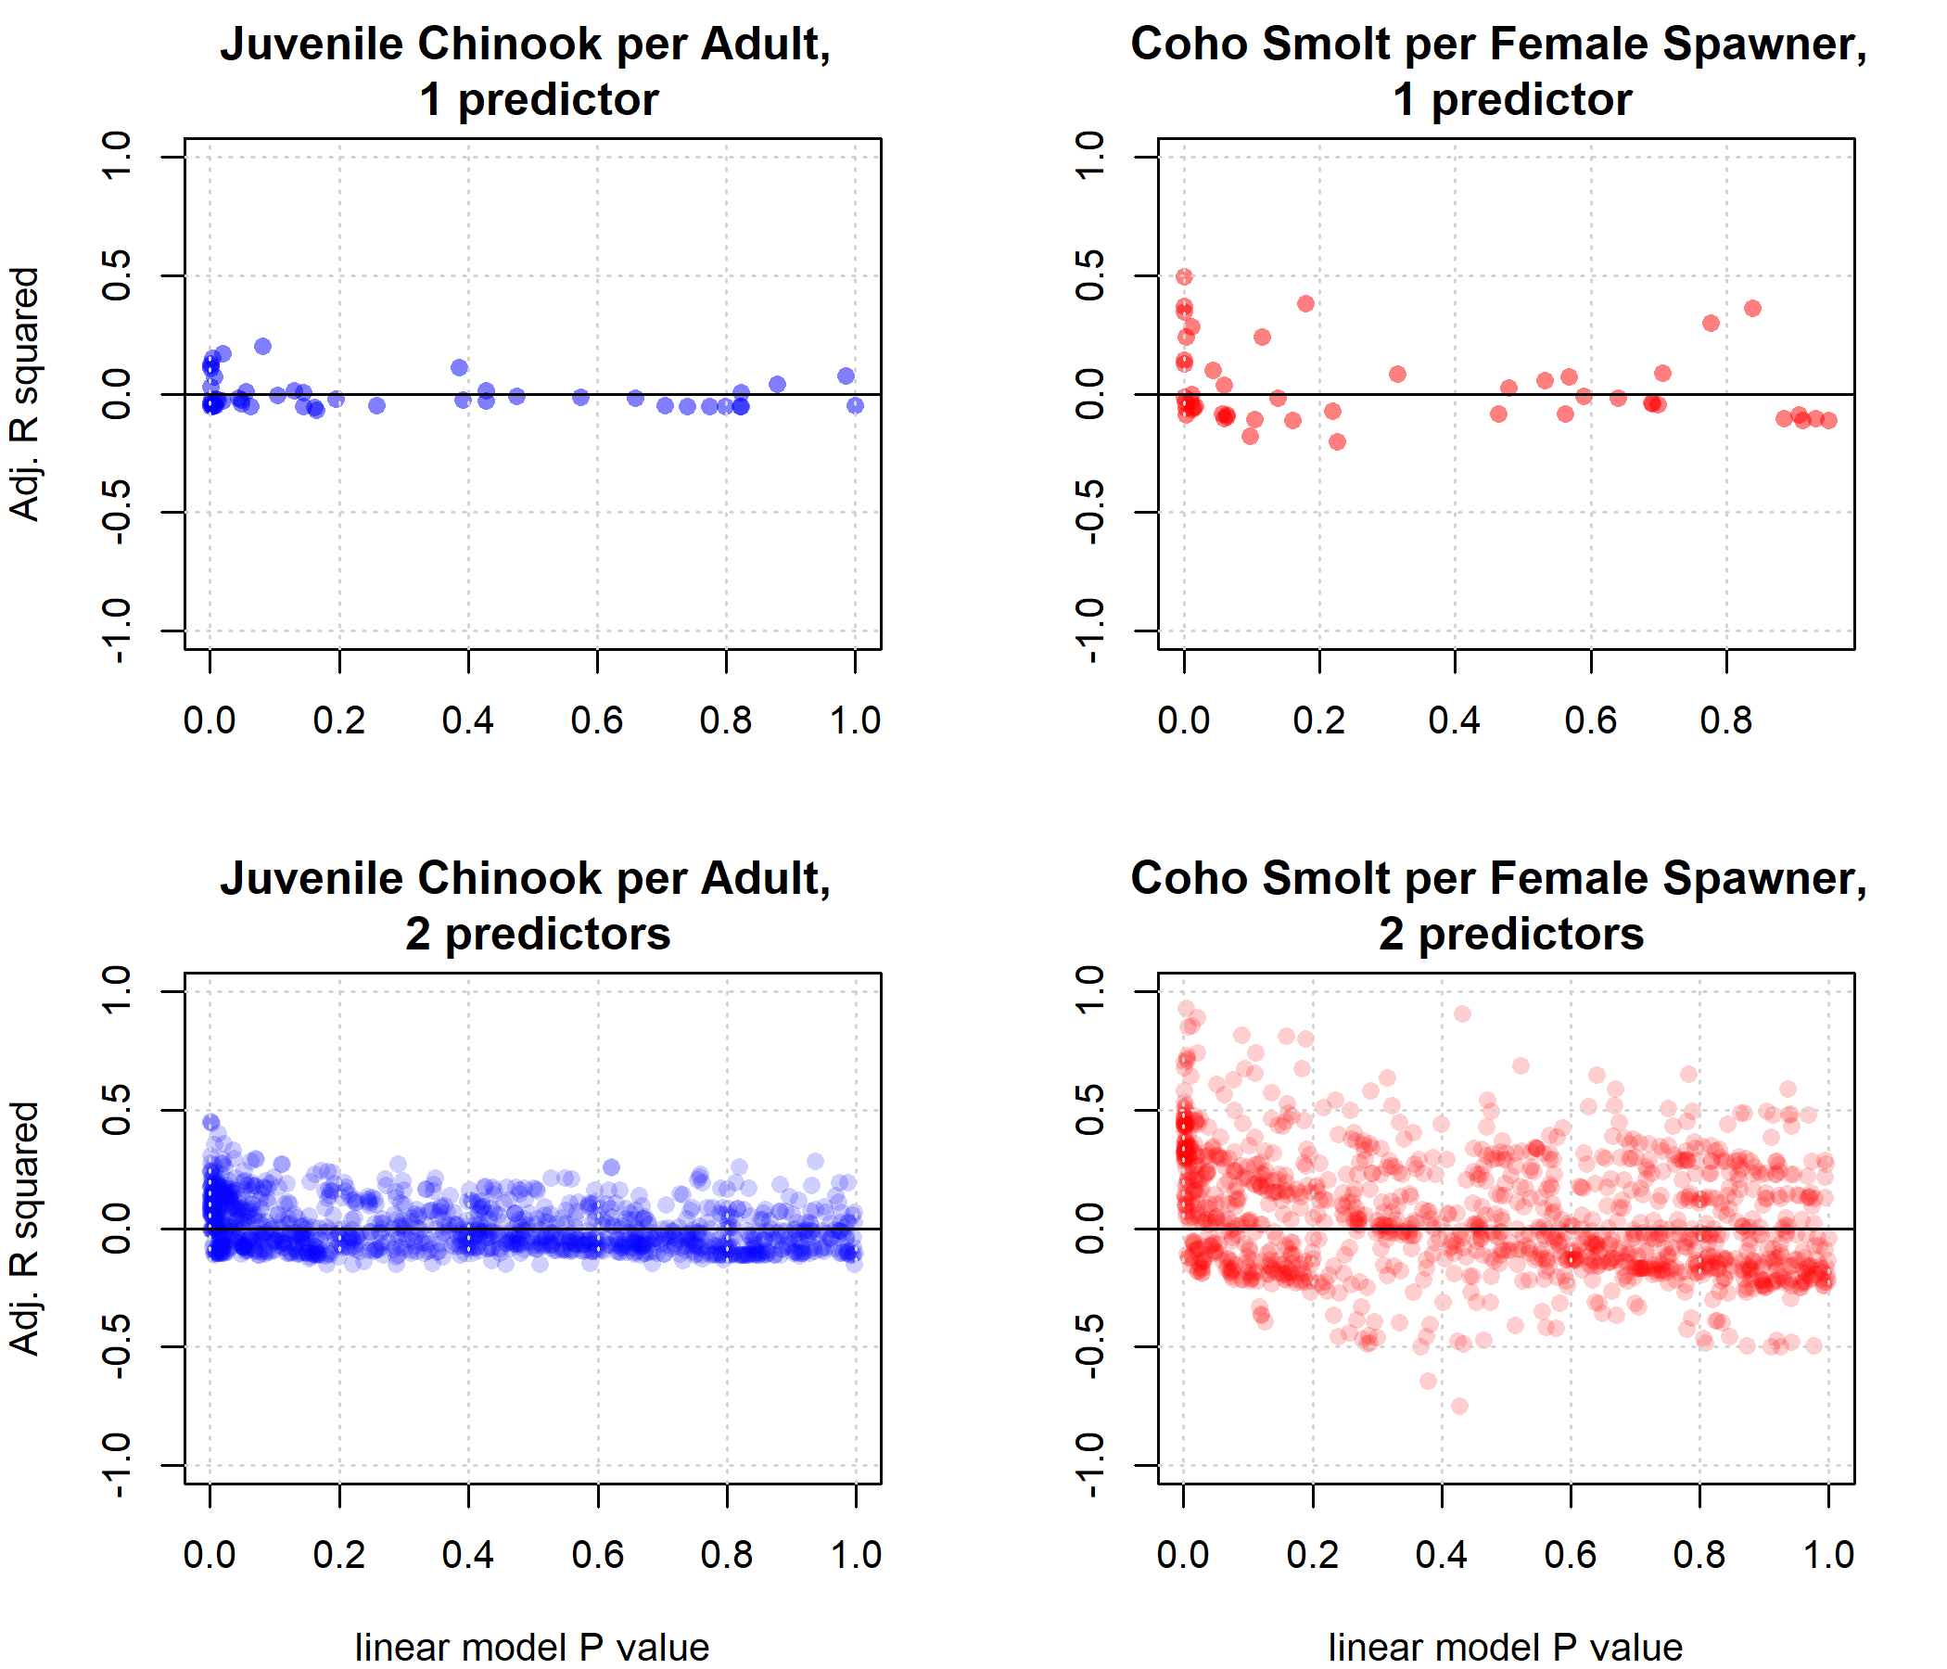

Figure 10: The adjusted R square and P values of all possible linear models (1- and 2-predictors) for Chinook and coho relative reproduction, using all hydrologic metrics described above. Based on the much lower predictability of Chinook outcomes, the flow-ecology prediction exercise was carried out only for coho salmon.

### 4.3.1 Hydrologic predictors and model structure

For coho, the best single-predictor models (Brood Year fall reconnection dates for 10 and 100 cfs, or BY_recon_10 and BY_recon_100) are both related to the timing of rising fall flows in the Brood Year of each salmon cohort (Table 2).

The predictor BY_FA_Mag, or the magnitude of the Brood Year fall pulse, was also highly correlated with coho spf (Figure 8). However, because a distinct fall pulse does not occur every year, including it would reduced the sample size to an unacceptable level (i.e., a total of six water years with a complete set of predictors and response observations). Because of this sample size limitation, and because some of the information about this pulse was carried in the reconnection date metric, FA_Mag was excluded from the set of potential predictors.

The addition of a second predictor clearly improves model performance in terms of predictive power and test error. This is evident in the greater abundance of 2-predictor models with higher and lower p-values (Figure 10; *Supplemental Tables 3* through *6*), as well as in the increased values, reduced AICc values, and reduced average error when comparing models lm2a and lm2b versus lm1a and lm1b (Tables 2 and 3; Figure 11).

### 4.3.2 Model selection criteria

The minimum performance criteria were established to select the final set of best model were: adjusted value of >0.6, a p-value of <0.2, an F-statistic of more than 10, and a LOOCV value of less than 747 (i.e., the LOOCV value of the best one-predictor model). The predictors and slopes of the three models which met these criteria (lm2a, lm2b, and lm2c) are shown in Table 4.

These criteria were selected using professional judgment based on the features of the available models, and the diversity of predictors in the resulting ensemble model. For example, the selection of a p-value criteria of <0.2 allowed the inclusion of lm2c (Table 2), with a p-value of 0.18, but excluded lm2d, with a p-value of 0.64. The authors felt that this was a reasonable cutoff in statistical significance for such a small sample size of observed response variable. Additionally, the three models that met these criteria incorporate information from the end of a dry season (BY_recon_10 and 100), the onset of the wet season (RY_Wet_Tim), and the wet season duration (Wet_BFL_Dur), which supports the professional judgment of the authors that the degree of hydro-ecological services provided each water year is best evaluated using information from multiple seasons.

For coho, because the predictor BY_recon_10 (Brood Year reconnection date, 10 cfs) performed so much better than all other metrics in the one-predictor model set, all two-predictor models evaluated included that predictor (Table 2). Specifically, each of the three two-predictor models which met the selection criterio included BY_recon_10 and an indication of the onset or duration of the following wet season: Brood Year reconnection date for 100 cfs (BY_recon_100), wet season onset or duration for the Rearing Year (RY_Wet_Tim and RY_Wet_BFL_Dur). (Though they both occur as the Brood Year transitions to the Rearing Year, the two metrics BY_recon_100 and RY_Wet_Tim are not highly correlated, due to the more complex criteria needed for a flow event to qualify as the wet season onset.)

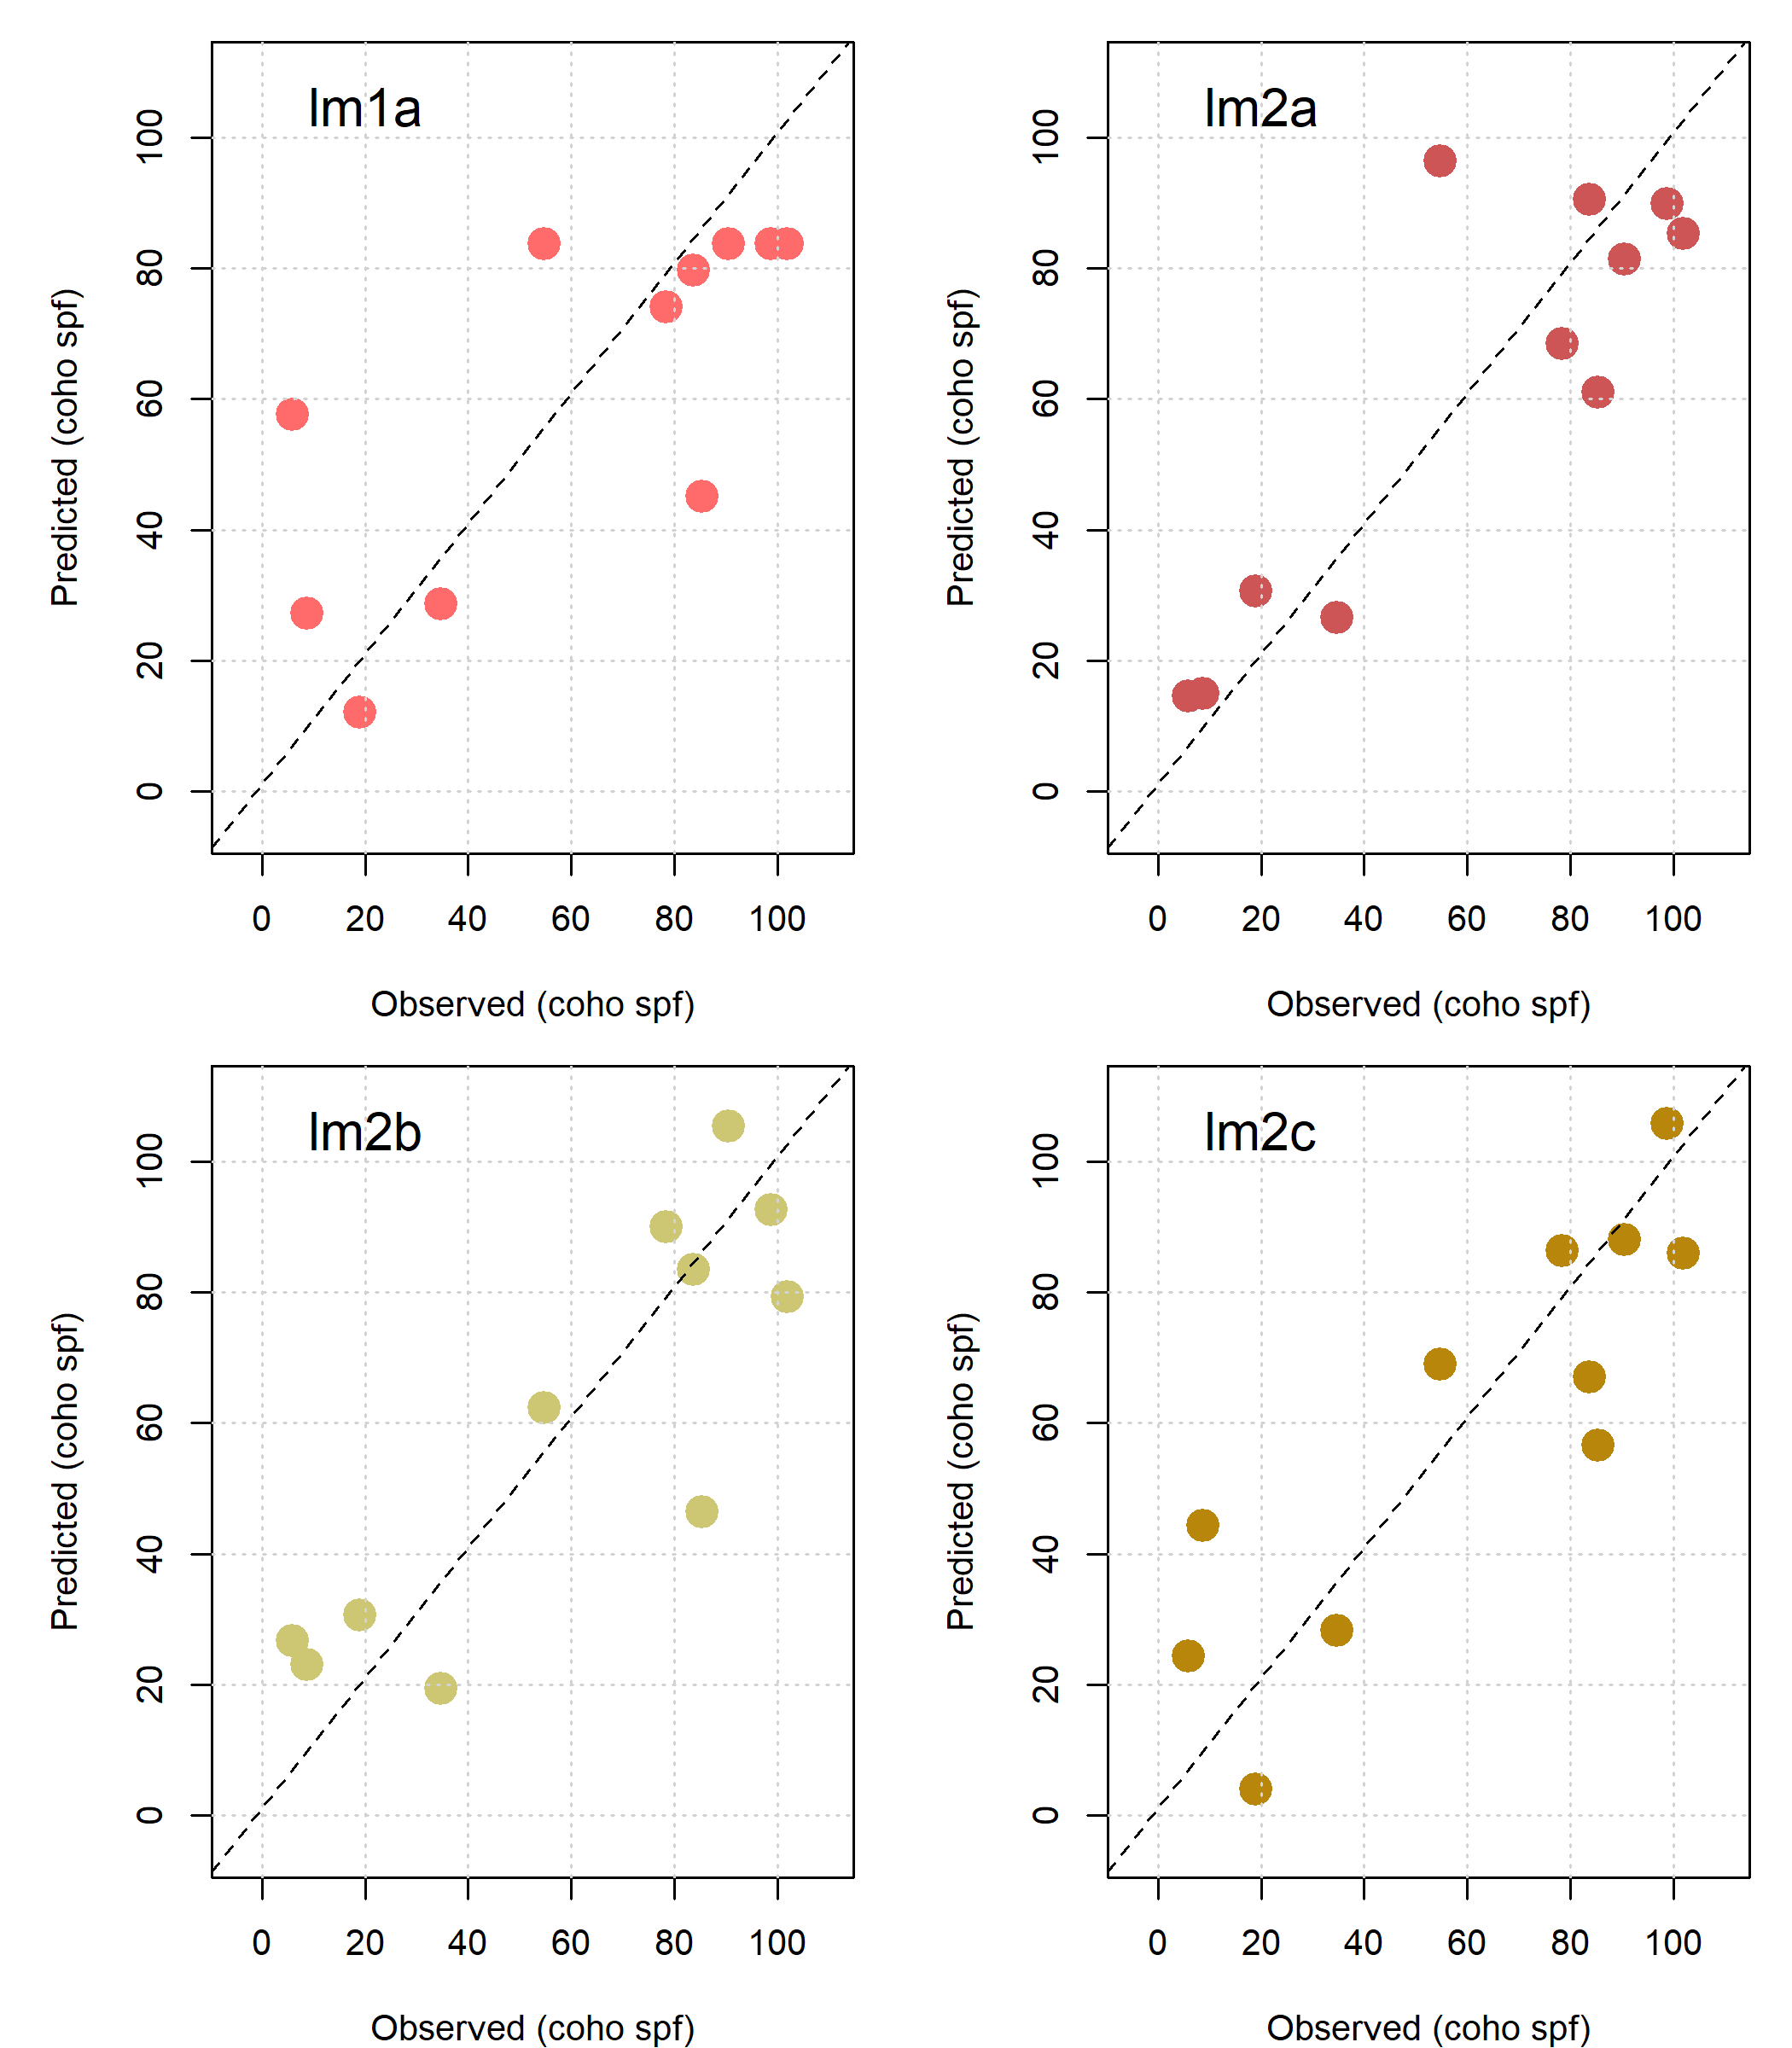

Figure 11: Predicted vs observed values for coho smolt production per female in the linear models with one through four hydrologic predictors. A dashed 1:1 line is included for reference.

## 4.4 Hydrologic Benefit Function

### 4.4.1 Predictors and coefficients in the ensemble model

To avoid over-interpreting results based on the small ecological dataset of coho reproduction, the coefficients of the three best two-predictor linear models ( in Equation 1) were averaged into the coefficients of an ensemble model shown in Table 4. The ensemble model coefficients provide the formulation of the Hydrologic Benefit function (Equation 2).

Where:

Table 2: Summary statistics of an example set of linear models predicting the number of coho smolt produced per female in a given water year. Because the Brood Year reconnection date for 10 cfs was by far the best single-predictor model, it is included in all two-predictor models under consideration.

| Model | Predictor(s) | F-stat. | P-value | R squared | Adj. R squared | AICc |
| --- | --- | --- | --- | --- | --- | --- |
| lm1a | BY_recon_10 | 10.8 | 0.00003 | 0.546 | 0.496 | 108.4 |
| lm1b | BY_recon_100 | 6.9 | 0.00056 | 0.434 | 0.371 | 110.8 |
| lm1c | RY_Wet_Tim | 4.1 | 0.00336 | 0.316 | 0.239 | 112.9 |
| lm1d | RY_Wet_BFL_Dur | 6.7 | 0.83792 | 0.427 | 0.363 | 110.9 |
| lm2a | BY_recon_10, BY_recon_100 | 12.9 | 0.00004 | 0.764 | 0.705 | 105.1 |
| lm2b | BY_recon_10, RY_Wet_Tim | 11.7 | 0.00017 | 0.745 | 0.681 | 106.0 |
| lm2c | BY_recon_10, RY_Wet_BFL_Dur | 11.4 | 0.18325 | 0.740 | 0.675 | 106.2 |
| lm2d | BY_recon_10, SY_SP_ROC | 10.2 | 0.64086 | 0.718 | 0.648 | 107.0 |
| lm2e | BY_recon_10, SY_Wet_Tim | 7.6 | 0.06299 | 0.654 | 0.568 | 109.3 |
| lm2f | BY_recon_10, RY_discon_10 | 6.9 | 0.47116 | 0.634 | 0.542 | 109.9 |

Table 3: Average model prediction error, based on leave-one-out cross-validation (James et al., 2013).

| Model | LOOCV value | Average error (coho spf-equiv.) |
| --- | --- | --- |
| lm1a | 747 | 27.3 |
| lm1b | 940 | 30.7 |
| lm1c | 1,165 | 34.1 |
| lm1d | 938 | 30.6 |
| lm2a | 579 | 24.1 |
| lm2b | 587 | 24.2 |
| lm2c | 703 | 26.5 |
| lm2d | 952 | 30.9 |
| lm2e | 706 | 26.6 |
| lm2f | 1,086 | 33.0 |

Table 4: Summary of slope values (coho smolt per female per relevant unit) for predictors included in the three best linear models. The ensemble average values are used as weights in the Hydrologic Benefit function.

| Model ID | Intercept | BY_recon_100 | RY_Wet_Tim | RY_Wet_BFL_Dur | BY_recon_10 |
| --- | --- | --- | --- | --- | --- |
| lm2a | 118.11 | -0.50 |  |  | -1.119810 |
| lm2b | 128.58 |  | -0.61 |  | -1.240451 |
| lm2c | 33.50 |  |  | 0.35 | -1.102907 |
| Ensemble Avg. | 93.39 | -0.17 | -0.20 | 0.12 | -1.154389 |

### 4.4.2 Hydrologic Benefit value over time and component contributions

Matching the historical flow trends discussed above (and tabulated in *Supplemental Table 2*), the predicted value of coho spf-equivalent produced by a given water year has trended downward over time (Figure 12). The hydrology of a severe drought in water years 2012-2016 is reflected in three consecutive years (2014-2016) of predicted coho spf being lower than 40.

Since 1990, the low predicted coho spf values in dry water years have become progressively lower, culminating in three years, all occurring after water year 2000, in which < 0 coho spf are predicted. Though a negative value for coho reproduction has no physical meaning, we chose to retain these impossible values to visually represent uncertainty associated with this modeling exercise (see Discussion for more information).

The relative influence of different terms in the ensemble average model varies over time: most variability in the 1940s-1970s is due to changes in wet season onset and wet season baseflow duration, but starting in the 1980s the fall flow reconnection timing tends to dominate predictions, especially during low-coho spf years (Figure 13; the intercept term is excluded for ease of visualization).

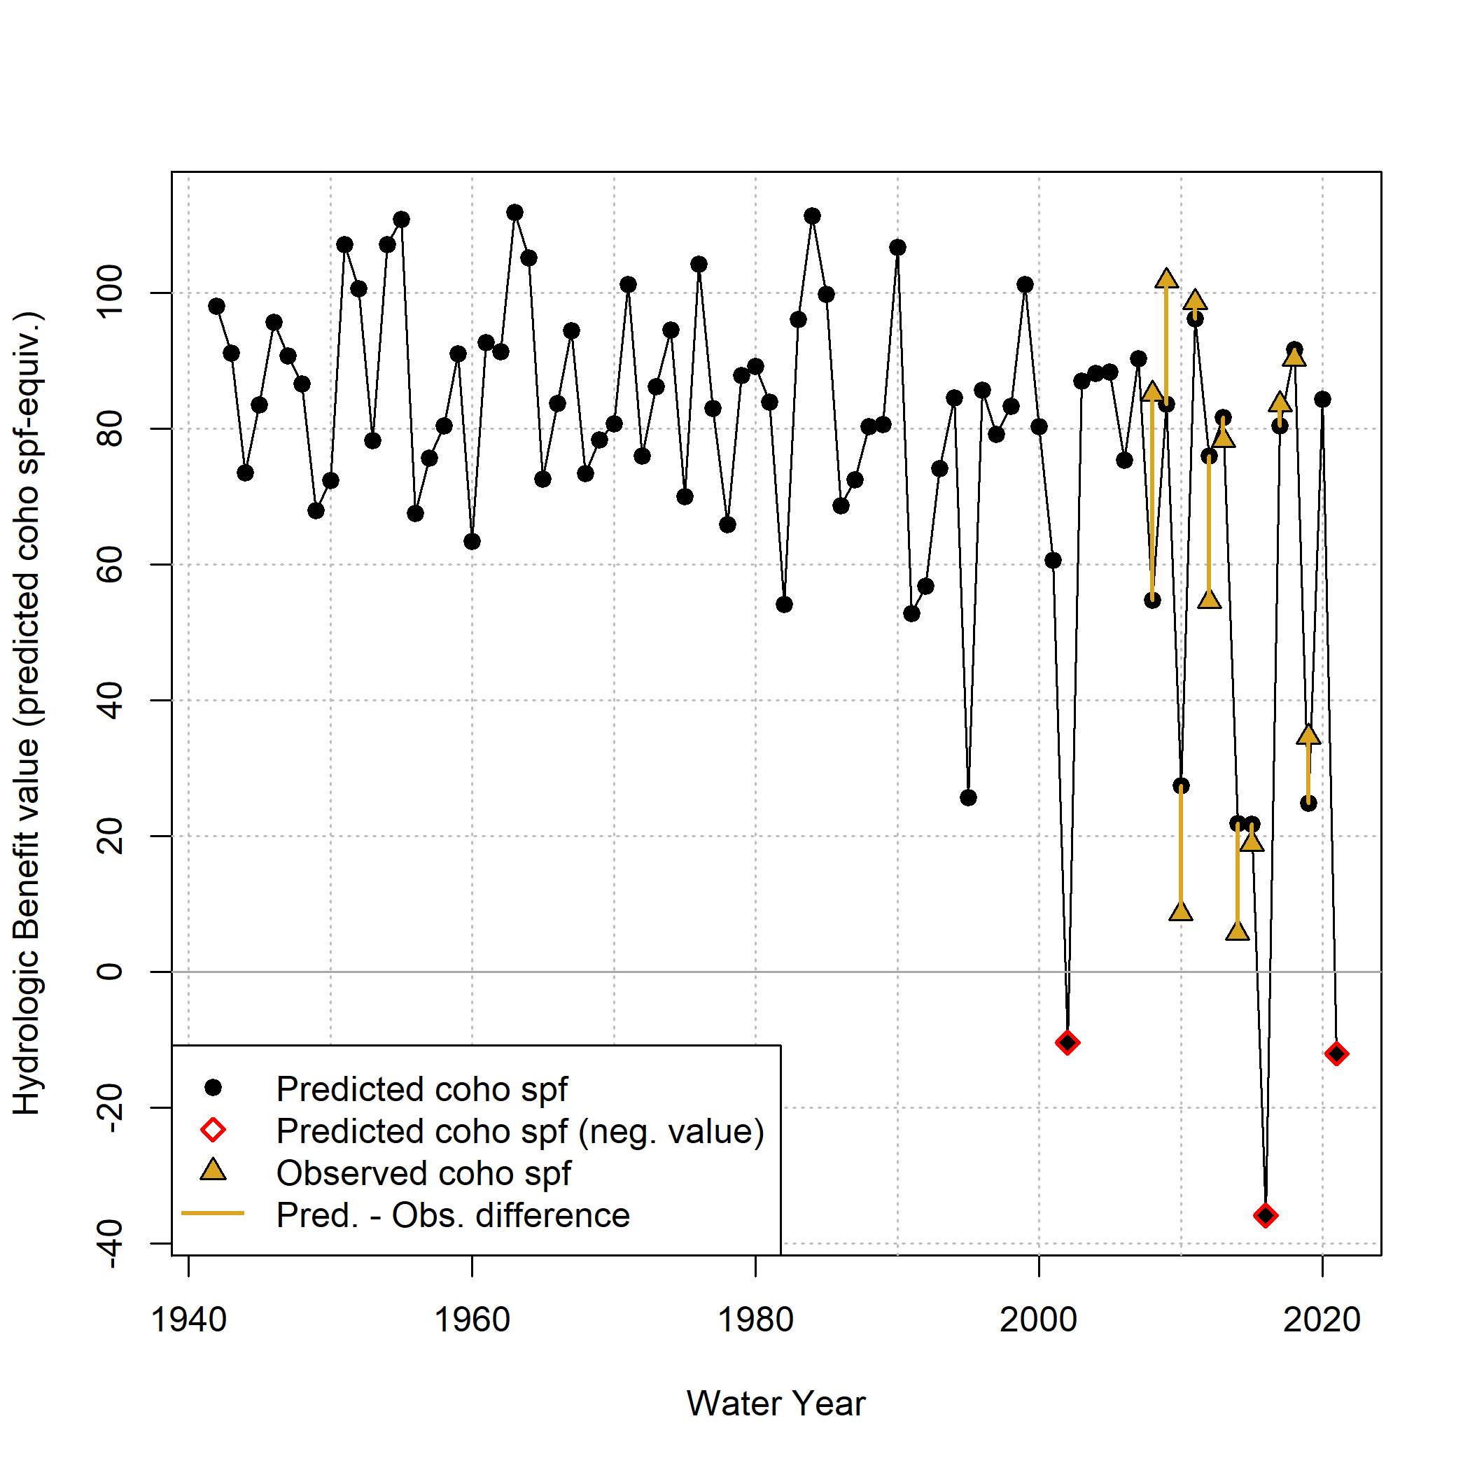

Figure 12: Annual observed and predicted values of coho smolt produced per female spawner (coho spf). Predicted coho spf quantities are shown as Hydrologic Benefit (HB) function values. The coho spf values are plotted in the water year spanning each cohort’s Brood and Rearing Year. Negative prediction values (considered physically impossible) are flagged but are retained to visually demonstrate the uncertainty in the exercise of predicting fish outcomes from hydrologic metrics alone, based on a small sample size.

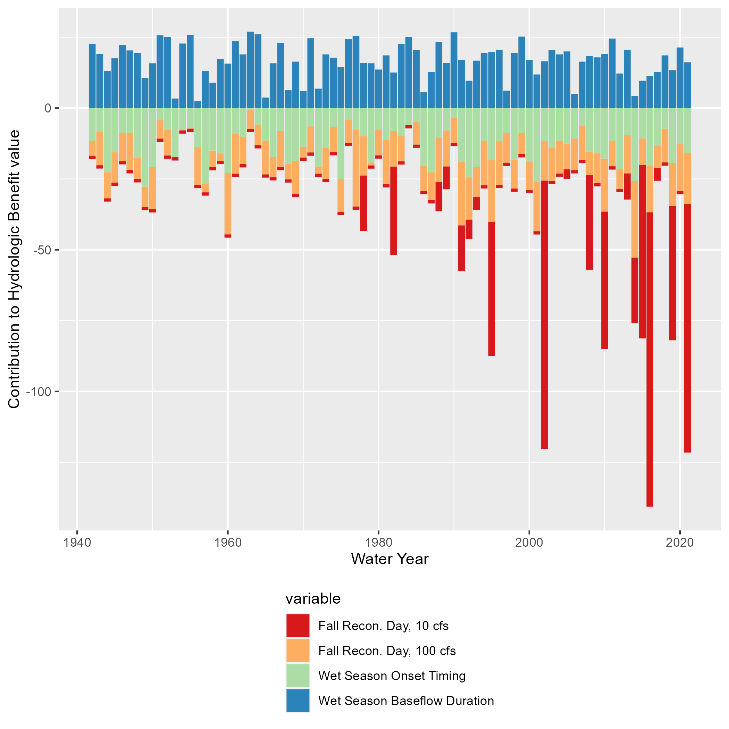

Figure 13: Contributions to annual Hydrologic Benefit values (coho spf-equivalent). A positive value (i.e., one associated with a water year’s Wet Season Baseflow Duration) indicates that a longer wet season baseflow duration contributes a positive value to the predicted number of coho spf produced in that cohort. A negative value (e.g., one associated with a water year’s Fall Reconnection Day at 10 cfs) indicates that a later reconnection date contributes a negative value to the predicted number of coho spf produced in that cohort.

### 4.4.3 Sensitivity of the Hydrologic Benefit function to one additional data point

Testing different values for the missing coho spf observation for brood year 2015 suggests that the best-fit HB function weights are relatively sensitive to the addition of one new data point, as can be expected for a small dataset. Flow conditions in and just before water year 2016 (affecting brood year 2015) were very dry, and the hydrologic predictors for water year 2016 generated the lowest predicted coho spf value of the entire Fort Jones gauge flow record (-35.9; see Figure 12).

Replacing this predicted negative value in 2016 (brood year 2015) with an “observed” coho spf value of 0 changes the coefficient (or conceptual weight) of the predictor BY_recon_10 from -1.15 to -0.88 (a difference of 24%). Replacing it with higher numbers produces less and less negative coefficient values. Specifically, a 1-coho spf increase in the missing value makes the coefficient less negative by 0.007 coho spf per day of 10-cfs reconnection delay, such that if it is replaced with the maximum observed coho spf value (101.8), the coefficient is calculated as -0.09 coho spf/day. The other three coefficients are not as sensitive to the new value, ranging from -0.17 – -0.19, -0.20 – -0.18, and 0.12 – 0.13 for BY_recon_100, RY_Wet_Tim, and RY_Wet_BFL_Dur, respectively, when the missing value is replaced by a range from 0 to 101.8.

# 5 Discussion

## 5.1 Previous work on hydrologic indices and ecological responses

In many previous studies of flow-ecology relationships, all the predictors used to model the ecological response are flow-derived metrics, because flow data is often continuous and more abundant than other data types. Such models rely on the assumption that spatial habitat extent (with flow as its proxy) or flow availability is the limiting factor in ecological recruitment, and thus that change in flow can be directly translated to a fish population response. However, this ignores ecological theory. Under many circumstances, complex internal population feedbacks (such as high juvenile fish density leading to some juvenile fish mortality) will be the limiting factor on fish population size. Consequently, many authors have argued that models of fish population responses to hydrologic changes should explicitly include ecological population modeling in addition to physical factors such as flow or geomorphology (Rosenfeld 2003; Anderson et al. 2006; Lancaster and Downes 2014; Acreman et al. 2014; Shenton et al. 2012). Additionally, in at least one case, fish population differences were not successfully predicted with a model based only on a predictor of flows; other variables such as water temperature were necessary to capture population shifts (McManamay et al. 2013).

In spite of these known limitations, the HB function proposed here uses only hydrologic predictors. In part this is a pragmatic approach, as this work is intended to set the foundation for assessing flow conditions in speculative hydrologic models, which do not simulate non-hydrologic, ecologically-relevant factors such as water quality or internal population dynamics. Furthermore, the hydrologic-only predictor approach may be more valid in this watershed than in a general case, as previous work suggests that flow availability is the major limiting factor on the local salmon fishery (SRWC and Siskiyou RCD 2005; NMFS 2014). Lastly, the proposed HB function avoids some of the disadvantages of the snapshot method of comparing the two states of natural and altered flows (Wheeler, Wenger, and Freeman 2018), because the hydro-ecological dataset is relatively long. This temporal structure, covering a wide range of water year types, makes it possible to test the hypothesis that a measurable relationship exists between hydrologic signal and ecologic response, even within an otherwise more complex relationship involving many non-hydrologic factors.

## 5.2 Critical flow thresholds

The river reconnection dates of multiple flow thresholds are correlated, to varying degrees, with biological monitoring data (see Results). These correlations support the current scientific understanding that the timing of restoration of habitat connectivity after dry periods in the Scott River is related to the reproductive success of spawning salmon (e.g., Siskiyou County 2021; *pers. comm.*, Sommarstrom 2020; SRWC 2018).

The selection of 10 and 100 cfs thresholds for fall flow reconnection dates is informed by both the empirical relationship between thresholds and coho spf observations (Figure 9) and professional judgment regarding which flows typically facilitate coho spawning passage into the valley and access to a large amount of tributary habitat. However, multiple caveats apply to these thresholds. First, though the timing of the 10 cfs reconnection had the strongest correlation with observed coho spf values, a flow of 18 to 25 cfs has been reported in stakeholder meetings as the minimum flowrate during which fish can pass upriver into Scott Valley (SVGAC 2020). Second, the extent to which the flow at the Fort Jones gauge represents conditions in the rest of the watershed depends on the speed of hydrologic processes taking place. When the transition from the dry season to the wet season is especially abrupt, flow in the tributaries may increase hours before the Fort Jones gauge flow responds (e.g. as was observed in response to the storm in late October of 2021).

Additional fish population monitoring in future water years will be instrumental in better constraining the nuances of these hydro-ecological relationships and the conditions in which hydrology can be used to predict outcomes for anadromous fish.

## 5.3 Predictability of Chinook versus coho salmon

In the dataset evaluated here, hydrologic metrics have a much greater capacity to predict reproduction in coho salmon than in Chinook. This difference may be due to any number of distinctions in the life history and reproductive strategies of the two species (see Section 2.2.4). Some possibilities include:

* Coho salmon prefer smaller tributary stream habitat for spawning, while Chinook prefer larger gravels found on the mainstem of the Scott River. Consequently, coho salmon may be more sensitive to the amount of river connectivity and thus total salmon-accessible habitat during their spawning window.
* Chinook typically do not oversummer in the freshwater system, potentially making them less vulnerable than coho to dry season conditions.
* Chinook populations may be more strongly affected by ocean conditions than coho salmon, possibly due to behavior differences during their period of ocean residence, which is not examined here. This factor may exert a more powerful control on the number of returning spawners than freshwater conditions.

Regardless of the ultimate cause(s), this difference in predictability underscores the fact that the prediction exercise undertaken in this study can only be performed successfully for some species and some regions.

## 5.4 Hydrologic Benefit (HB) function predictive performance and sensitivity

For the 11 years in which observed coho spf values are available, the HB function was reasonably accurate in its predictions (Figure 12). In particular, it succeeded in predicting whether a coho spf year would be above or below 40 (an arbitrary threshold based on visual inspection of the grouping of the 11 observed values). A more conservative use of this model would be to assign a high-low threshold, and categorize each water year as a “high-coho spf” or “low-coho spf” year based on its relation to this threshold. However, for purposes of this discussion we retain the full distribution of values.

These linear models have been developed for a Coho Freshwater Life Period (see Figure 3 ), but the relevant time period for decisionmakers is typically a water year or shorter. It was possible to select a set of best models that fit within one water year, in that they range from the fall of the Brood Year through the wet season of the immediately following Rearing Year. With this formulation, a prediction could be made each fall, using the flow record of the preceding water year and the estimated number of female spawners during the previous fall-winter, regarding the number of smolts to be observed in the coming spring. This smolt abundance prediction could be made to test the model quality when confronted with new data.

The predictive power of the Hydrologic Benefit formula beyond the hydrologic conditions of water years 2007-2020 remains untestable; for this reason the coho spf prediction values of water years pre-2007 should be treated with skepticism. Notably, the hydrologic phenomena that constitute the limiting factors on salmon reproduction might have been very different in the watershed in past decades (e.g., if fall flows were not a major constraint, then spring rearing habitat, or possibly scouring storm flows in winter, might show stronger correlations with coho reproduction).

Additionally, the sensitivity exercise indicated that even one additional data point can alter the ensemble coefficient, or weight, of the most important predictor (Brood Year reconnection timing, 10 cfs) by at least 24%; thus it is reasonable to assume that if more data is collected in the future, the HB function coefficients and possibly even the set of best hydrologic predictors may shift. Nevertheless, the limited data available can be used to draw some preliminary conclusions regarding bio-hydrologic relationships in the Scott River watershed.

## 5.5 Metric weights and importance

The relative contributions of each metric, shown in Figure 13, indicate that the weighted metric introducing the greatest variability in coho spf predictions is the reconnection date at the 10 cfs threshold; in other words, an important common feature of the water years that yield very low coho spf predictions is a relatively long fall period of flow <10 cfs.

Figure 13 also highlights that three of the four selected hydrologic metrics are negatively correlated with coho spf values. This means the HB function relies on a positive intercept value to generate positive coho spf predictions, and because the intercept value can be outweighed by combinations of flow metric values that are within the range of possibility, this formulation allows the prediction of negative values. A negative value, or a prediction of coho smolt consumption rather than production, is obviously not possible based on our understanding of the coho salmon life cycle (Figure 3).

Unfortunately, observed coho spf values are not available for any of the water years in which a negative value is predicted (2002, 2016 and 2021; Figure 12), so a direct comparison of prediction accuracy is not possible in these water years. However, given that the coho run persisted in the Scott River watershed beyond the 3-year cohort-return interval (i.e., water years 2005 and 2019), some smolt production greater than 0 in these years is highly likely.

The metrics most related to watershed-scale coho spf occur during the window of their parents’ spawning and, to a lesser extent, in the winter through summer of their early rearing. At least three potential mechanisms have been hypothesized regarding the importance of fall flow timing and magnitude to coho salmon. During dry water years, when fall reconnection dates are delayed, coho have been known to spawn in suboptimal habitat (e.g., Siskiyou RCD 2014). Eggs laid in suboptimal conditions suffer from higher mortality rates for multiple reasons, including egg burial by transported sediment, channel bed scouring, or unfavorable water quality (Bjornn and Reiser 1991). Additionally, anadromous fish do not eat during spawning, and a delayed reconnection date, with a corresponding longer waiting period before spawning habitat becomes accessible, leads to higher rates of exhaustion and potentially higher mortality during spawning in long high-elevation spawning migrations (e.g., sockeye salmon in Crossin et al. 2004). Finally, early reconnection flows and related access to more and higher-quality habitat may allow spawning salmon to select more favorable nesting sites, which could exert a controlling influence on the mortality rates of the young produced that year.

It is also notable that the metrics with the highest predictive power are associated with negative values, or coho spf penalties. One possible interpretation is that hydrologic metrics can be useful for identifying unfavorable conditions for coho salmon, but are not sufficient to describe favorable conditions. The ecological theory that may explain this further is beyond the scope of this paper, but could be a focus of future studies.

## 5.6 Implications for water and fisheries management

This study represents a contribution to the large body of work seeking to understand and conserve aquatic ecosystems in the Klamath basin, and in aquatic ecosystems in Mediterranean climates more generally. Viability of the SONCC ESU population of coho salmon has been examined at a regional scale in the past, though conclusions were preliminary, due to data limitations (Williams et al. 2006, 2008). A proposed framework to assess viability included the following factors (Williams et al. 2008):

* Effective population size
* Population size per generation
* Population decline (rate of decline)
* Catastrophic decline (order of magnitude decline within 1 generation)
* Spawner density
* Potential spatial habitat capacity, in units of Intrinsic Potential (IP)
* Hatchery influence
* Extinction risk from population viability analysis model

This work can potentially help managers understand some of the mechanisms driving the population size per generation dimension of this viability schematic - though its predictive power is limited to being relative to the size of the escapement.

We note also that any adaptive management other than flow management (e.g., water use or habitat restoration) will introduce (and surely has already introduced) confounding factors into this modeling exercise. For example, extreme dry conditions and high occurrence of fish stranding in water year 2014 led agencies and local organizations to conduct an unprecedented juvenile salmon rescue operation (CDFW 2015a). It is possible the coho spf for water year (and Rearing Year) 2014 would have been even lower without that intervention (although this is hard to judge; it is also possible that the translocation stressed the fish and may have led to increased mortality rates). Future work may be able to estimate the independent coho population impact of these non-flow adaptive management tactics.

We expect pieces of this approach could be employed in other regional studies, though in systems with shorter or minimal ecological monitoring records, opportunities to find correlations between flow and biological metrics may be sample size-limited to an even greater degree than in this study. However, this study may show the value of even a dozen years of monitoring data in a range of water year types, and could provide motivation to continue investing in data collection and the monitoring of sensitive species.

# 6 Conclusions

This case study uses the functional flow framework and long-term biological monitoring to relate hydrologic conditions to watershed-scale anadromous fish reproduction rates. The empirical flow-biology relationships evaluated here also suggest hypotheses regarding the watershed-specific mechanisms of ecological response to flow variability.

To learn if it was possible to empirically quantify a hydrologic regime that meets the ecological needs of coho salmon in the Scott River watershed, we examined correlations between several dozen hydrologic metrics and local salmon observations. We found several metrics, both from prior studies (Patterson et al. 2020; Yarnell et al. 2020) and designed for this study (Figure 5), that appeared correlated with the number of coho smolts produced per female spawner (coho spf). The two flow metrics most correlated with the coho spf of a given smolt cohort were the first date after the dry season of flows rising above 10 and 100 cfs, respectively, during the spawning window for the cohort’s parents. This suggests that in the Scott River watershed, flow conditions and habitat access during spawning may be the greatest single factor in a brood’s success, affecting the cohort from the egg stage through outmigration to the ocean.

We used linear models to predict coho spf values for each water year based on potential combinations of one and two hydrologic metric predictors. The intercept and slopes of the three best of these linear models were aggregated to formulate a Hydrologic Benefit function (Figure 12). With this formulation, a prediction could be made each fall, using the flow hydrology of the preceding water year and the estimated number of female spawners during the previous fall-winter, regarding the number of smolts to be observed in the coming spring. It can also be applied to the river flow output of hydrologic models simulating various management scenarios, to estimate the impact of infrastructure or regulation on local salmon reproduction.

Conversely, we did not find that Chinook reproduction observations could be predicted with as much success as coho using the same set of hydrologic data. This suggests that the utility of this type of analysis is both region- and species-dependent.

With continuing trends of a narrowing wet season in the Scott River watershed (e.g., Figure 7), entities aiming to sustain local fisheries may find themselves working with ever-thinner margins for error. Globally, in communities living and working with local natural resources, climate change may transform biodiversity-preservation activities into long-term engineering of novel ecosystems. If this occurs, long-term monitoring and frequently re-evaluated flow-ecology relationships will be necessary to support such efforts.

Acreman, Mike, Angela H. Arthington, Matthew J. Colloff, Carol Couch, Neville D. Crossman, Fiona Dyer, Ian Overton, Carmel A. Pollino, Michael J. Stewardson, and William Young. 2014. “Environmental flows for natural, hybrid, and novel riverine ecosystems in a changing world.” *Frontiers in Ecology and the Environment* 12 (8): 466–73. <https://doi.org/10.1890/130134>.

Agrawal, A, R S Schick, E P Bjorkstedt, R G Szerlong, M N Goslin, B C Spence, T H Williams, K M Burnett, and National Oceanic. 2005. “NOAA Technical Memorandum NMFS PREDICTING THE POTENTIAL FOR HISTORICAL COHO , CHINOOK AND STEELHEAD HABITAT IN NORTHERN CALIFORNIA,” no. June.

Anderson, Kurt E., Andrew J. Paul, Edward McCauley, Leland J. Jackson, John R. Post, and Roger M. Nisbet. 2006. “Instream flow needs in streams and rivers: The importance of understanding ecological dynamics.” *Frontiers in Ecology and the Environment* 4 (6): 309–18. [https://doi.org/10.1890/1540-9295(2006)4[309:IFNISA]2.0.CO;2](https://doi.org/10.1890/1540-9295(2006)4%5b309:IFNISA%5d2.0.CO;2).

Arthington, A. H., J. M. Bernardo, and M. Ilhéu. 2014. “Temporary Rivers: Linking Ecohydrology, Ecological Quality and Reconciliation Ecology.” *River Research and Applications* 30 (August): 1209–15. <https://doi.org/10.1002/rra>.

Bjornn, T. C., and D. W. Reiser. 1991. “Habitat Requirements of Salmonids in Streams.” In *Influences of Forest and Rangeland Management on Salmonid Fishes and Their Habitats*, edited by W. R. Meehan, 83–138. Special Publication 19. Bethesda, Maryland: American Fisheries Society. <https://doi.org/10.2307/1446234>.

Bourret, Samuel L., Christopher C. Caudill, and Matthew L. Keefer. 2016. “Diversity of juvenile Chinook salmon life history pathways.” *Reviews in Fish Biology and Fisheries* 26 (3): 375–403. <https://doi.org/10.1007/s11160-016-9432-3>.

Bradford, Michael J, Garth C Taylor, J Andrew Allan, Michael J Bradford, Garth C Taylor, J Andrew Allan Empirical, Michael J Bradford, Garth C Taylor, and J Andrew Allan. 2016. “Empirical Review of Coho Salmon Smolt Abundance and the Prediction of Smolt Production at the Regional Level.” *Transactions of the American Fisheries Society* 126 (June): 48–64. [https://doi.org/10.1577/1548-8659(1997)126<0049](https://doi.org/10.1577/1548-8659(1997)126%3c0049).

Brown, Larry R., Peter B. Moyle, and Ronald M. Yoshiyama. 1994. “Historical Decline and Current Status of Coho Salmon in California.” *North American Journal of Fisheries Management* 14 (2): 237–61. [https://doi.org/10.1577/1548-8675(1994)014<0237:hdacso>2.3.co;2](https://doi.org/10.1577/1548-8675(1994)014%3c0237:hdacso%3e2.3.co;2).

Bunn, Stuart E., and Angela H. Arthington. 2002. “Basic principles and ecological consequences of altered flow regimes for aquatic biodiversity.” *Environmental Management* 30 (4): 492–507. <https://doi.org/10.1007/s00267-002-2737-0>.

Bustard, David R., and David W. Narver. 1975. “Aspects of the Winter Ecology of Juvenile Coho Sahnon (Oncorhynchus kisutch) and Steelhead Trout (Salmo gairdneri).” *Journal of the Fish Resources Board of Canada* 32: 667–80.

California Department of Fish and Wildlife (CDFW). 2015a. “Cooperative Report of the Scott River Coho Salmon Rescue and Relocation Effort: 2014 Drought Emergency.” August. California Department of Fish; Wildlife (CDFW). [https://www.fs.usda.gov/Internet/FSE{\_}DOCUMENTS/stelprd3850544.pdf](https://www.fs.usda.gov/Internet/FSE%7b_%7dDOCUMENTS/stelprd3850544.pdf).

———. 2015b. “Recovery Strategy for California Coho Salmon Progress Report 2004-2012.” California Department of Fish; Wildlife (CDFW). [http://www.fgc.ca.gov/meetings/2015/Aug/Exhibits/0805{\_}Item{\_}38{\_}CohoStatusReport.pdf](http://www.fgc.ca.gov/meetings/2015/Aug/Exhibits/0805%7b_%7dItem%7b_%7d38%7b_%7dCohoStatusReport.pdf).

———. 2017. “Interim Instream Flow Criteria for the Protection of Fishery Resources in the Scott River Watershed, Siskiyou County.” California Department of Fish; Wildlife (CDFW). <https://wildlife.ca.gov/Conservation/Watersheds/Instream-Flow/Studies/Scott-Shasta-Study>.

California North Coast Regional Water Quality Control Board (NCRWQCB). 2006. “Report for the Action Plan for the Shasta River Watershed Temperature and Dissolved Oxygen Total Maximum Daily Loads,” 1123.

California State Water Resources Control Board (SWRCB). 2022. “Establishment of Minimum Instream Flow Requirements, Curtailment Authority, and Information Order Authority in the Klamath Watershed.” Sacramento, CA. [https://www.waterboards.ca.gov/drought/scott{\_}shasta{\_}rivers/docs/2022/klamath-reg-oal-approval-2022.pdf](https://www.waterboards.ca.gov/drought/scott%7b_%7dshasta%7b_%7drivers/docs/2022/klamath-reg-oal-approval-2022.pdf).

CDFW. 2021. “Scott River Best Available Scientific Information for Instream Flow Criteria and Potential Next Steps.” California Department of Fish; Wildlife (CDFW).

Crossin, G. T., S. G. Hinch, A. P. Farrell, D. A. Higgs, A. G. Lotto, J. D. Oakes, and M. C. Healey. 2004. “Energetics and morphology of sockeye salmon: Effects of upriver migratory distance and elevation.” *Journal of Fish Biology* 65 (3): 788–810. <https://doi.org/10.1111/j.0022-1112.2004.00486.x>.

Drake, Daniel J., Kenneth W. Tate, and Harry Carlson. 2000. “Analysis shows climate-caused decreases in Scott River fall flows.” *California Agriculture* 54 (6): 46–49. <https://doi.org/10.3733/ca.v054n06p46>.

DWR. 2021. “Agricultural Land & Water Use Estimates.” <https://water.ca.gov/Programs/Water-Use-And-Efficiency/Land-And-Water-Use/Agricultural-Land-And-Water-Use-Estimates>.

Foglia, Laura, Alison McNally, Courtney Hall, Lauren Ledesma, Ryan Hines, and Thomas Harter. 2013. “Scott Valley Integrated Hydrologic Model : Data Collection , Analysis , and Water Budget.” April. University of California, Davis. <http://groundwater.ucdavis.edu/files/165395.pdf>.

Graham, Rhea. 2012. “Klamath River Basin Restoration Nonuse Value Survey.” [https://kbifrm.psmfc.org/wp-content/uploads/2016/12/Graham{\_}2012{\_}0010{\_}Klamath-River-Basin-Restoration-Nonuse-Value-Survey-Final-Report.pdf](https://kbifrm.psmfc.org/wp-content/uploads/2016/12/Graham%7b_%7d2012%7b_%7d0010%7b_%7dKlamath-River-Basin-Restoration-Nonuse-Value-Survey-Final-Report.pdf).

Hain, Ernie F., Jonathan G. Kennen, Peter V. Caldwell, Stacy A. C. Nelson, Ge Sun, and Steven G. McNulty. 2018. “Using regional scale flow–ecology modeling to identify catchments where fish assemblages are most vulnerable to changes in water availability.” *Freshwater Biology* 63 (8): 928–45. <https://doi.org/10.1111/fwb.13048>.

Harter, Thomas, and Ryan Hines. 2008. “Scott Valley Community Groundwater Study Plan,” 98. <http://groundwater.ucdavis.edu/files/136426.pdf>.

Healey, M. C. 1991. “Life History of Chinook Salmon (Onchorhynchus tshawytscha).” In *Pacific Salmon Life Histories*, edited by C. Groot and L. Margolis, 313–93. Vancouver: University of British Columbia Press.

Hunt, Sharon L, Timothy J Mulligan, and Kenichiro Komori. 1999. “Oceanic feeding habits of chinook salmon, Oncorhynchus tshawytscha, off northern California.” *Fishery Bulletin* 97 (October 1998): 717–21.

James, Gareth, Daniela Witten, Trevor Hastie, and Robert Tibshirani. 2013. *An Introduction to Statistical Learning*. 7th ed. New York: Springer Science+Business Media. <https://doi.org/10.1007/978-1-4614-7138-7>.

Knechtle, Morgan, and Diana Chesney. 2012. “2012 Scott River Salmon Studies.” Yreka, CA: California Department of Fish; Wildlife (CDFW). <https://nrm.dfg.ca.gov/FileHandler.ashx?DocumentID=77836>.

Knechtle, Morgan, and Domenic Giudice. 2020. “2019 Scott River Salmon Studies.” 530. Yreka, CA: California Department of Fish; Wildlife (CDFW).

———. 2021. “2020 Scott River Salmon Studies, Final Report.” Yreka, CA: California Department of Fish; Wildlife (CDFW).

Lancaster, Jill, and Barbara J. Downes. 2014. “Linking the hydraulic world of individual organisms to ecological processes: putting ecology into ecohydraulics.” *River Research and Applications* 30 (January): 132–33. <https://doi.org/10.1002/rra>.

Larsen, Stefano, Bruno Majone, Patrick Zulian, Elisa Stella, Alberto Bellin, Maria Cristina Bruno, and Guido Zolezzi. 2021. “Combining Hydrologic Simulations and Stream-network Models to Reveal Flow-ecology Relationships in a Large Alpine Catchment.” *Water Resources Research* 57 (4). <https://doi.org/10.1029/2020WR028496>.

Mack, Seymour. 1958. “Geology and Ground-Water Features of Scott Valley Siskiyou County, California.” Geological Survey Water-Supply Paper 1462. <https://pubs.usgs.gov/wsp/1462/report.pdf>.

Massie, Margaret, and Harrison Morrow. 2020. “2020 Scott River Juvenile Salmonid Outmigrant Study.” Yreka, CA: California Department of Fish; Wildlife.

Maurer, Sue. 2003. “Scott River Watershed Adult Coho Salmon Spawning Survey December 2002-January 2003.” Etna, CA: Siskiyou RCD.

Mazor, Raphael D., Jason T. May, Ashmita Sengupta, Kenneth S. McCune, Brian P. Bledsoe, and Eric D. Stein. 2018. “Tools for managing hydrologic alteration on a regional scale: Setting targets to protect stream health.” *Freshwater Biology* 63 (8): 786–803. <https://doi.org/10.1111/fwb.13062>.

McMahon, Thomas E. 1983. “Habitat Suitability Index Models: Coho Salmon. U.S. Dept. Int., Fish Wildl. Serv. FWS/OBS-92/10.49.” Fort Collins, CO: U.S. Dept. Int., U.S. Fish; Wildlife Service. FWS/OBS-92/10.49.

McManamay, Ryan A, Donald J Orth, Charles A Dolloff, and David C Mathews. 2013. “Application of the ELOHA Framework to Regulated Rivers in the Upper Tennessee River Basin: A Case Study.” *Environmental Management* 51: 1210–35. <https://doi.org/10.1007/s00267-013-0055-3>.

Moyle, P. B. 2002. *Inland Fishes of California*. University of California Press.

———. 2014. “Novel aquatic ecosystems: the new reality for streams in California and other Mediterranean climate regions.” *River Research and Applications* 30 (January): 1335–44. <https://doi.org/10.1002/rra>.

NCRWQCB. 2005. “Staff Report for the Action Plan for the Scott River Watershed Sediment and Temperature Total Maximum Daily Loads.” North Coast Regional Water Quality Control Board. [https://www.waterboards.ca.gov/water{\_}issues/programs/tmdl/records/region{\_}1/2010/ref3872.pdf](https://www.waterboards.ca.gov/water%7b_%7dissues/programs/tmdl/records/region%7b_%7d1/2010/ref3872.pdf).

Nickelson, Thomas E, Jeffrey D Rodgers, Steven L Johnson, and Mario F Solazzi. 1992. “Seasonal Changes in Habitat Use by Juvenile Coho Salmon (Oncorhynchus kisutch) in Oregon Coastal Streams.” *Canadian Journal of Fisheries and Aquatic Sciences* 49: 783–89.

NMFS. 2014. “Final SONCC Coho Recovery Plan - Scott River Population.” <https://www.fisheries.noaa.gov/resource/document/final-recovery-plan-southern-oregon-northern-california-coast-evolutionarily>.

Olden, Julian D., and N. L. Poff. 2003. “Redundancy and the choice of hydrologic indices for characterizing streamflow regimes.” *River Research and Applications* 19 (2): 101–21. <https://doi.org/10.1002/rra.700>.

Parry, Ashley. 2013. “Evaluation and modernization of the Scott Valley Irrigation District.” PhD thesis. <https://doi.org/10.1017/CBO9781107415324.004>.

Patterson, Noelle K., Belize A. Lane, Sarah M. Yarnell, Yexuan Qiu, Samuel Sandoval-Solis, and Gregory B. Pasternack. 2020. “A hydrologic feature detection algorithm to quantify seasonal components of flow regimes.” *Journal of Hydrology* 585 (June).

Peek, Ryan, Katie Irving, Sarah M. Yarnell, Rob Lusardi, Eric D. Stein, and Raphael Mazor. 2022. “Identifying Functional Flow Linkages Between Stream Alteration and Biological Stream Condition Indices Across California.” *Frontiers in Environmental Science* 9 (January): 1–14. <https://doi.org/10.3389/fenvs.2021.790667>.

Poff, N. L., J David Allan, Mark B Bain, James R Karr, Karen L Prestegaard, Brian D Richter, Richard E Sparks, and Julie C Stromberg. 1997. “A paradigm for river conservation and restoration.” *BioScience* 47 (11): 769–84. <https://doi.org/10.2307/1313099>.

Poff, N. L., Brian D. Richter, Angela H. Arthington, Stuart E. Bunn, Robert J. Naiman, Eloise Kendy, Mike Acreman, et al. 2010. “The ecological limits of hydrologic alteration (ELOHA): A new framework for developing regional environmental flow standards.” *Freshwater Biology* 55 (1): 147–70. <https://doi.org/10.1111/j.1365-2427.2009.02204.x>.

Poff, N. L., and Julie K. H. Zimmerman. 2010. “Ecological responses to altered flow regimes: A literature review to inform the science and management of environmental flows.” *Freshwater Biology* 55 (1): 194–205. <https://doi.org/10.1111/j.1365-2427.2009.02272.x>.

Quigley, Danielle. 2007. “Final Report Adult Coho Spawning Ground Surveys 2006-2007.” Etna, CA: Siskiyou RCD. <https://www.siskiyourcd.com/resources>.

Quiñones, Rebecca M., Marcel Holyoak, Michael L. Johnson, and Peter B. Moyle. 2014. “Potential factors affecting survival differ by run-timing and location: Linear mixed-effects models of Pacific salmonids (Oncorhynchus spp.) in the Klamath River, California.” *PLoS ONE* 9 (5): 1–12. <https://doi.org/10.1371/journal.pone.0098392>.

R Core Team. 2020. “R: A Language and Environment for Statistical Computing.” Vienna, Austria: R Foundation for Statistical Computing. <https://www.r-project.org/>.

Robertson, G. Philip, and Scott M. Swinton. 2005. “Reconciling agricultural productivity and environmental integrity: A grand challenge for agriculture.” *Frontiers in Ecology and the Environment* 3 (1 SPEC. ISS.): 38–46. <https://doi.org/10.2307/3868443>.

Rosenfeld, Jordan. 2003. “Assessing the Habitat Requirements of Stream Fishes: An Overview and Evaluation of Different Approaches.” *Transactions of the American Fisheries Society* 132 (5): 953–68. <https://doi.org/10.1577/t01-126>.

Scott River Water Trust (SRWT). 2018. “2017 Monitoring Report.” June. <https://www.scottwatertrust.org/blank>.

Scott Valley Area Plan Committee. 1980. “Scott Valley Area Plan (SVAP).”

Shenton, Will, Nicholas R. Bond, Jian D. L. Yen, and Ralph Mac Nally. 2012. “Putting the ecology into environmental flows: Ecological dynamics and demographic modelling.” *Environmental Management* 50 (1): 1–10. <https://doi.org/10.1007/s00267-012-9864-z>.

Siskiyou County Flood Control and Water Conservation District. 2021. “Scott Valley Groundwater Sustainability Plan.” Siskiyou County Flood Control; Water Conservation District. <https://www.co.siskiyou.ca.us/naturalresources/page/scott-valley-gsp-chapters>.

Siskiyou County GSA - Scott Valley Groundwater Advisory Committee. 2020. “Siskiyou County Groundwater Sustainability Agency Scott Valley Groundwater Advisory Committee Meeting.” Fort Jones, CA: Siskiyou County. <https://www.co.siskiyou.ca.us/scottvga/page/scott-valley-groundwater-advisory-committee-meeting-10>.

Siskiyou RCD. 1994. “Scott Valley Irrigation District Study.”

———. 2004. “Final Report. Scott River Coho Spawning Assessment: 2003-2004.” <https://www.siskiyourcd.com/resources>.

———. 2005. “Scott River Watershed Adult Coho Spawning Ground Surveys. November 2004-January 2005.” Etna, CA. <https://www.siskiyourcd.com/resources>.

———. 2006. “Final Report Scott River Adult Coho Spawning Ground Surveys November 2005 – January 2006.” Etna, CA. <https://www.siskiyourcd.com/resources>.

———. 2010. “Scott River Adult Coho Spawning Ground Surveys December 2009-January 2010.” <https://www.siskiyourcd.com/resources>.

———. 2011. “Scott River adult coho spawning ground surveys, 2010-2011 Season.” Siskiyou RCD. <https://www.siskiyourcd.com/resources>.

———. 2012. “Scott River Adult Coho Spawning Ground Surveys, 2011 Season.” <https://www.siskiyourcd.com/resources>.

———. 2013. “Scott River Adult Coho Spawning Ground Surveys 2012-2013 Season.” <https://www.siskiyourcd.com/resources>.

———. 2014. “Scott River Adult Coho Spawning Ground Surveys 2013-2014 Season.” <https://www.siskiyourcd.com/resources>.

———. 2015a. “Ranch Water Quality Plan Template.” February. Etna, CA. <https://www.siskiyourcd.com/resources>.

———. 2015b. “Scott River Fall Chinook Spawning Ground Surveys.” March. Etna, CA. <https://www.siskiyourcd.com/resources>.

———. 2017a. “Scott River Adult Coho Spawning Ground Surveys 2016-2017 Season Report.” June. Etna, CA. <https://www.siskiyourcd.com/resources>.

———. 2017b. “Scott River Fall Chinook Spawning Ground Surveys.” January. Etna, CA. <https://www.siskiyourcd.com/resources>.

———. 2018. “Scott River Fall Chinook Spawning Ground Surveys 2017 Season.” January. Etna, CA. <https://www.siskiyourcd.com/resources>.

Solans, M. Alba, and D. García de Jalón. 2016. “Basic tools for setting environmental flows at the regional scale: application of the ELOHA framework in a Mediterranean river basin.” *Ecohydrology* 9 (8): 1517–38. <https://doi.org/10.1002/eco.1745>.

Sommarstrom, Sari. 2020. “Email communication regarding connectivity of Scott River tailings reach, Nov. 18, 2020.”

SRWC. 2005. “Limiting Factors Analysis for Coho Salmon and other Anadromous Fish.”

———. 2018. “Restoring Priority Coho Habitat in the Scott River Watershed Modeling and Planning Report.” Etna, CA. <https://www.scottriverwatershedcouncil.com/scott-river-westside-planning-proje>.

SRWC-CRMP. 2000. “Final Report.”

SRWC, and Siskiyou RCD. 2003. “Scott River Fall Flows Action Plan Accomplishments, 1995 to 2003.” January. Etna, CA.

Superior Court of Siskiyou County. 1980. “Scott River Adjudication, Decree No. 30662. Scott River stream system, Siskiyou County. California State Water Resources Control Board.” Sacramento, CA. [https://www.waterboards.ca.gov/waterrights/board{\_}decisions/adopted{\_}orders/judgments/docs/scottriver{\_}jd.pdf](https://www.waterboards.ca.gov/waterrights/board%7b_%7ddecisions/adopted%7b_%7dorders/judgments/docs/scottriver%7b_%7djd.pdf).

Tarlock, A. Dan. 1993. “Local Government Protection of Biodiversity: What Is Its Niche?” *University of Chicago Law Review* 60 (2): 555–613.

Tolley, Douglas G., Laura Foglia, and Thomas Harter. 2019. “Sensitivity Analysis and Calibration of an Integrated Hydrologic Model in an Irrigated Agricultural Basin with a Groundwater-Dependent Ecosystem.” *Water Resources Research* 55 (8). <https://doi.org/10.1029/2018WR024209>.

U.S. Census Bureau. 2021. “2020 Decennial Census.” <https://data.census.gov/cedsci>.

Van Kirk, Robert W., and Seth W. Naman. 2008. “Relative effects of climate and water use on base-flow trends in the lower Klamath Basin.” *Journal of the American Water Resources Association* 44 (4): 1035–52. <https://doi.org/10.1111/j.1752-1688.2008.00212.x>.

Wainwright, Thomas C, Thomas H Williams, Kurt L Fresh, and Brian K Wells. 2013. “CCIEA Phase II Report: Ecosystem Components, Fisheries and Protected Species - Salmon: CHINOOK AND COHO SALMON.” NOAA NMFS. <https://swfsc-publications.fisheries.noaa.gov/publications/CR/2013/2013Wainwright.pdf>.

Welch, David Warren, Aswea Dawn Porter, and Erin Leanne Rechisky. 2021. “A synthesis of the coast-wide decline in survival of West Coast Chinook Salmon (Oncorhynchus tshawytscha, Salmonidae).” *Fish and Fisheries* 22: 194–211. <https://doi.org/10.1111/faf.12514>.

Wheeler, Kit, Seth J. Wenger, and Mary C. Freeman. 2018. “States and rates: Complementary approaches to developing flow-ecology relationships.” *Freshwater Biology* 63 (8): 906–16. <https://doi.org/10.1111/fwb.13001>.

White, James C., Andy House, Neil Punchard, David M. Hannah, Nicholas A. Wilding, and Paul J. Wood. 2018. “Macroinvertebrate community responses to hydrological controls and groundwater abstraction effects across intermittent and perennial headwater streams.” *Science of the Total Environment* 610-611: 1514–26. <https://doi.org/10.1016/j.scitotenv.2017.06.081>.

Williams, Thomas H, Eric P Bjorkstedt, Walt G Duffy, Mike Mccain, Mike Rode, and R Glenn Szerlong. 2006. “Historical population structure of Coho Salmon in Southern Oregon/Northern California coasts evolutionary significant unit.” National Oceanic; Atmosphecric Administration (NOAA) National Marine Fisheries Service (NMFS). <https://repository.library.noaa.gov/view/noaa/3483>.

Williams, Thomas H, Brian C Spence, Tom E Lisle, Thomas E Nickelson, and Tom Pearson. 2008. “Framework for assessing viability of threatened coho salmon in the Southern Oregon/Northern California Coast Evolutionarily Significant Unit.” National Oceanic; Atmosphecric Administration (NOAA) National Marine Fisheries Service (NMFS). <https://repository.library.noaa.gov/view/noaa/3609>.

Yarnell, Sarah M., Eric D. Stein, J. Angus Webb, Theodore Grantham, Rob A. Lusardi, Julie Zimmerman, Ryan A. Peek, Belize A. Lane, Jeanette Howard, and Samuel Sandoval-Solis. 2020. “A functional flows approach to selecting ecologically relevant flow metrics for environmental flow applications.” *River Research and Applications* 36 (2): 318–24. <https://doi.org/10.1002/rra.3575>.

Yokel, E, Shari K Witmore, B Stapleton, C Gilmore, and M M Pollock. 2018. “Scott River Beaver Dam Analogue Coho Salmon Habitat Restoration Program 2017 Monitoring Report.” <https://www.scottriverwatershedcouncil.com/scott-river-beaver-dam-analogue-coh>.